**Task on Auto Scaling Groups (ASG)**

1. **title: Create one VPC in N. Virginia region.**

**objective:** we need to create one VPC in N. Virginia region that will create virtual orivate networks, subnets

**prerequisites:**

**vpc name**

**cidr**

**step by step process:**

**Step 1: Create a VPC (N. Virginia Region)**

* Console Path: VPC → Your VPCs → Create VPC
* CIDR: 10.0.0.0/16
* Region: us-east-1 (N. Virginia)
* Explanation: Creates an isolated virtual network for all resources.

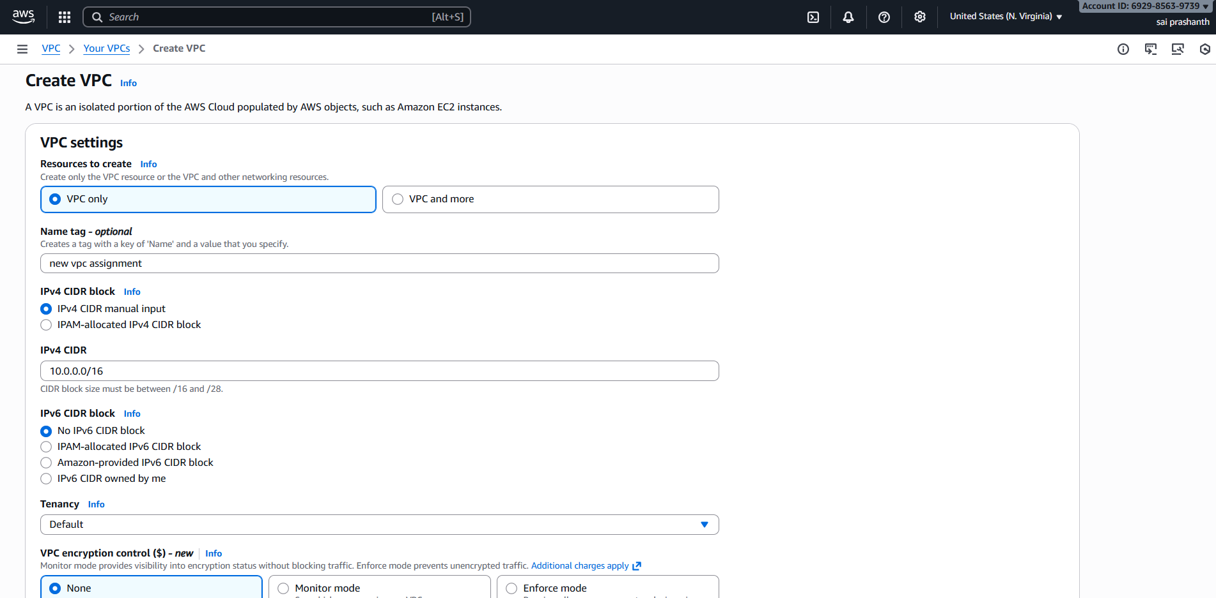

after creating click on create vpc

**validation steps**:

now you can see the vpc has been created

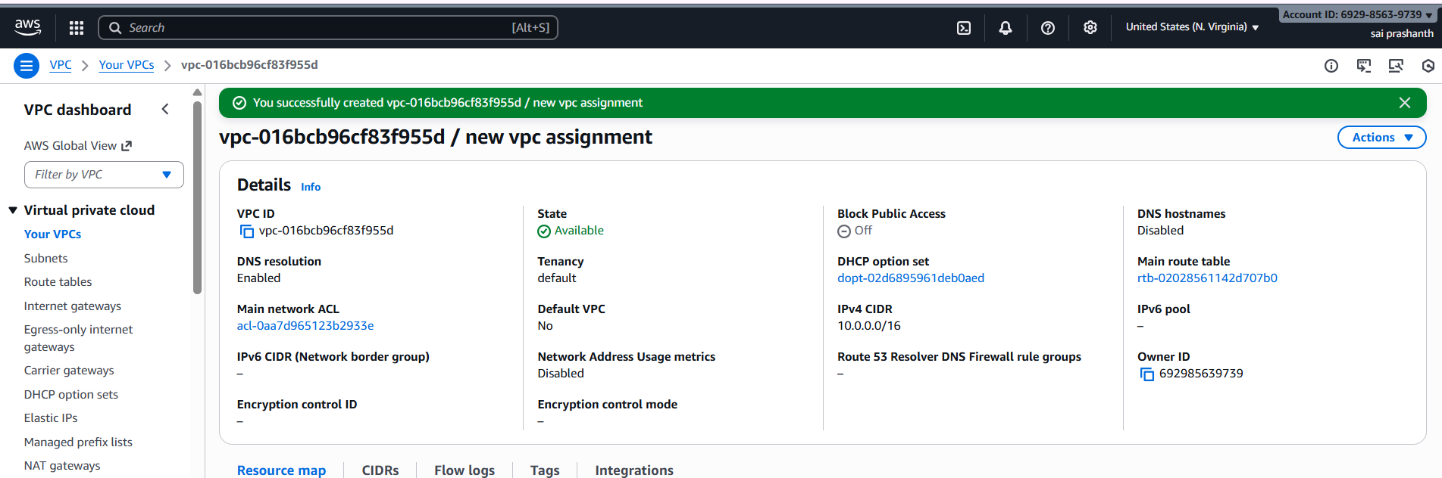

conclusion : now the vpc has been created with one cidr range and with name new vpc assignment

1. **title: Create Public & Private Subnets**

**objective:** we need to create one public and private subnets

**step by step process:**

* Public Subnet: 10.0.1.0/24
* Private Subnet: 10.0.2.0/24
* Console Path: VPC → Subnets → Create subnet
* Explanation: Public subnet for internet-facing resources; private subnet for backend. 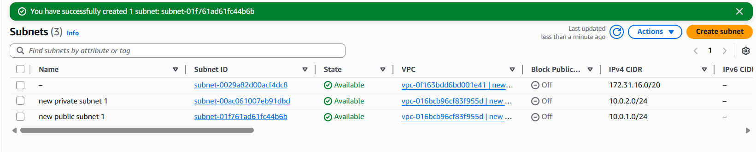

conclusion :

now we have created two subnets—one is public and one is private.

**3: title: Create and Attach Internet Gateway (IGW)**

**objective : we need to create one internet gateway and we need to attach to public subnet**

**step by step process:**

* Console Path: VPC → Internet Gateways → Create IGW
* Attach IGW to the created VPC
* Explanation: Enables internet access for public subnet.

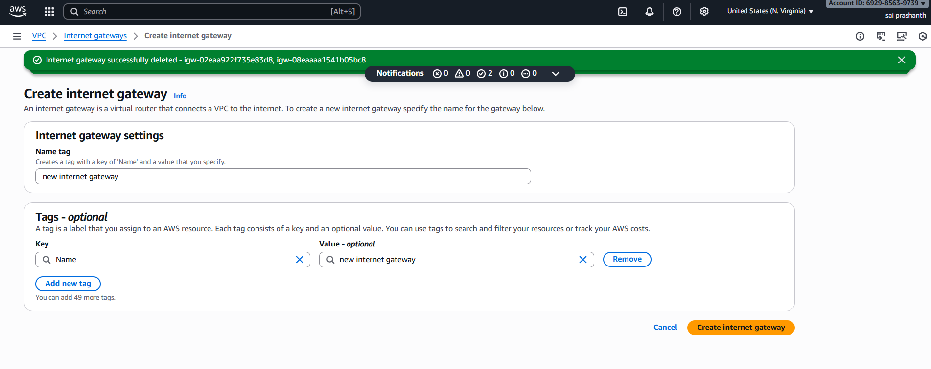

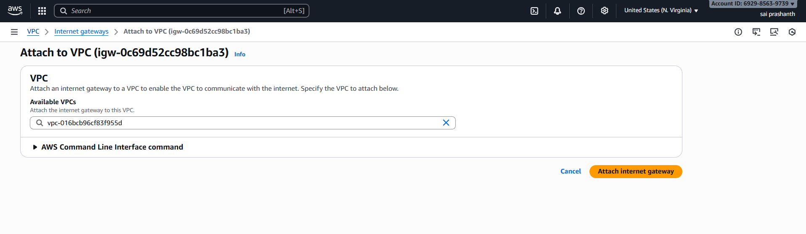

**validation steps :**

**now you can ssee internet gateway has been attached to vpc**

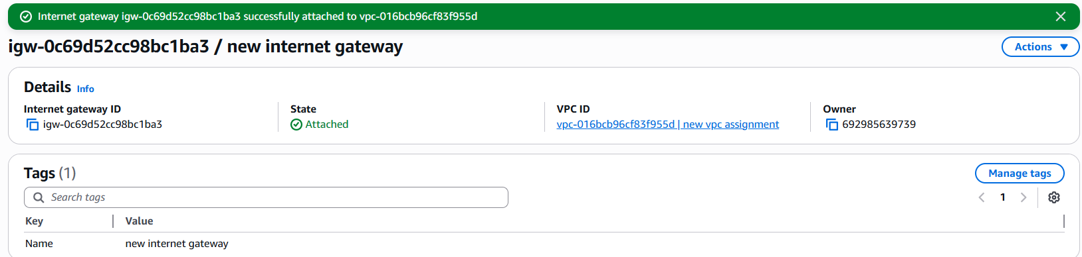

1. **title: Create Public & Private Route Tables**

**objective: we need to create route tables for both public and private to set the traffic**

**step by step process :**

* **Public RT → Route: 0.0.0.0/0 → IGW**
* **Private RT → Will be updated with NAT Gateway**
* **Associate Public RT with Public Subnet**
* **Associate Private RT with Private Subnet**



**now we have attached internet gateway access to the public subnet**

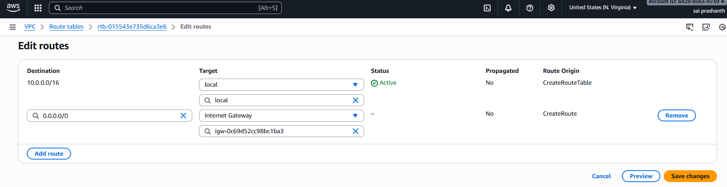

**validation steps:**

**now you can see the internet gateway has been attached to public subnet**

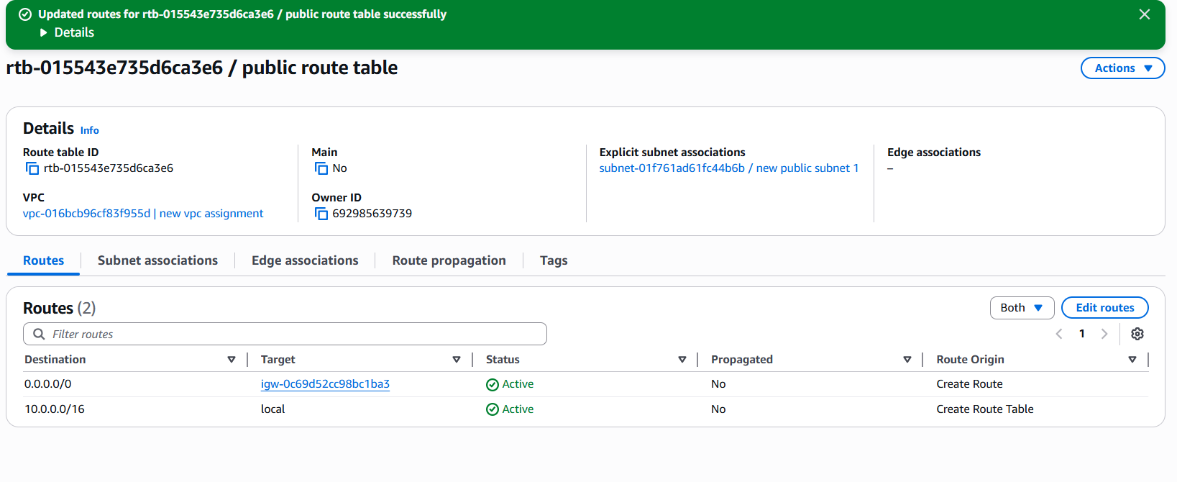

1. **title: Create NAT Gateway in Public Subnet**

**objective :** we need to set one nat gateway and need to allow internet access for private subnet

**step by step process :**

* Allocate Elastic IP
* Create NAT Gateway in Public Subnet
* Update Private Route Table: 0.0.0.0/0 → NAT Gateway
* Explanation: Allows outbound internet access for private subnet.

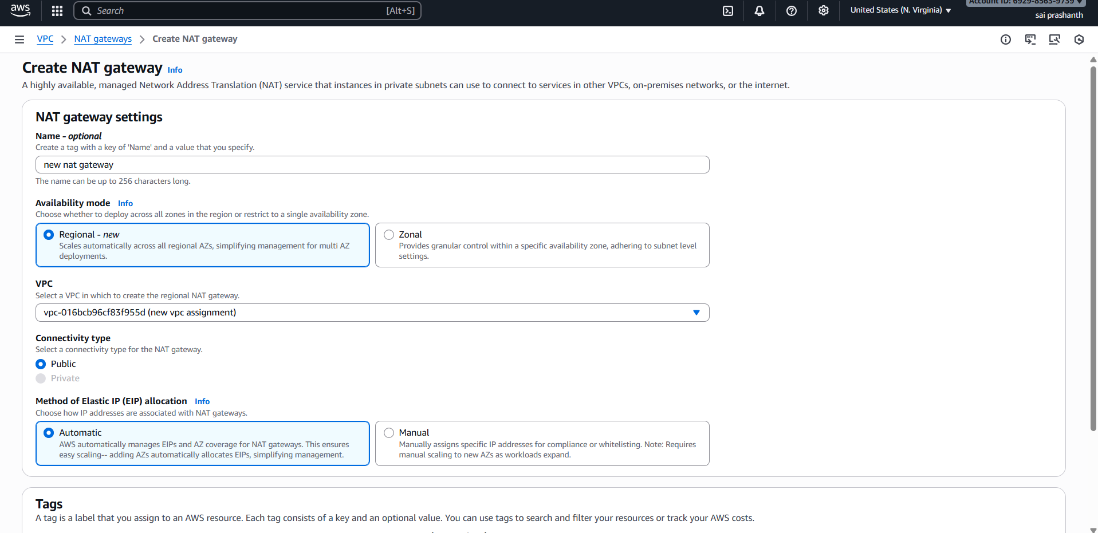

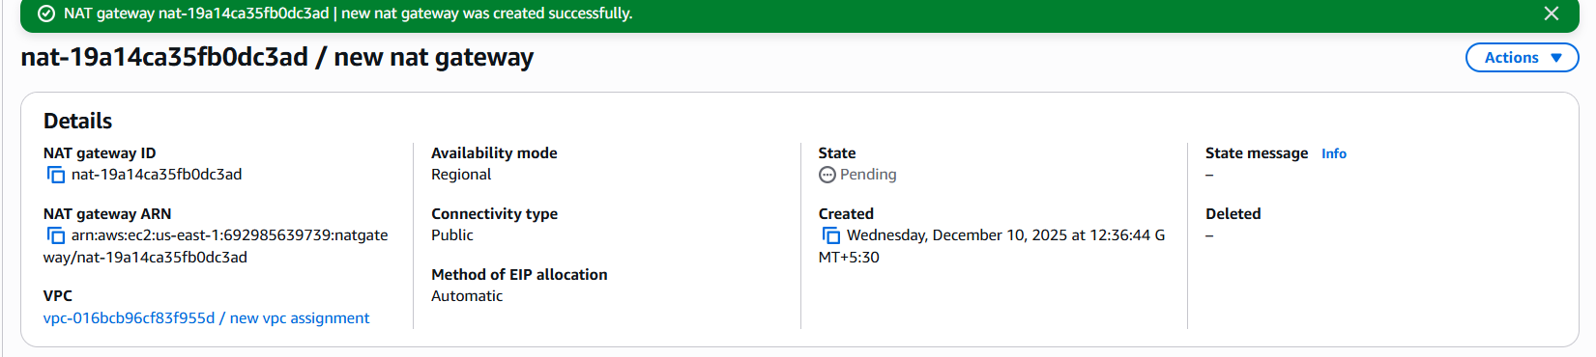

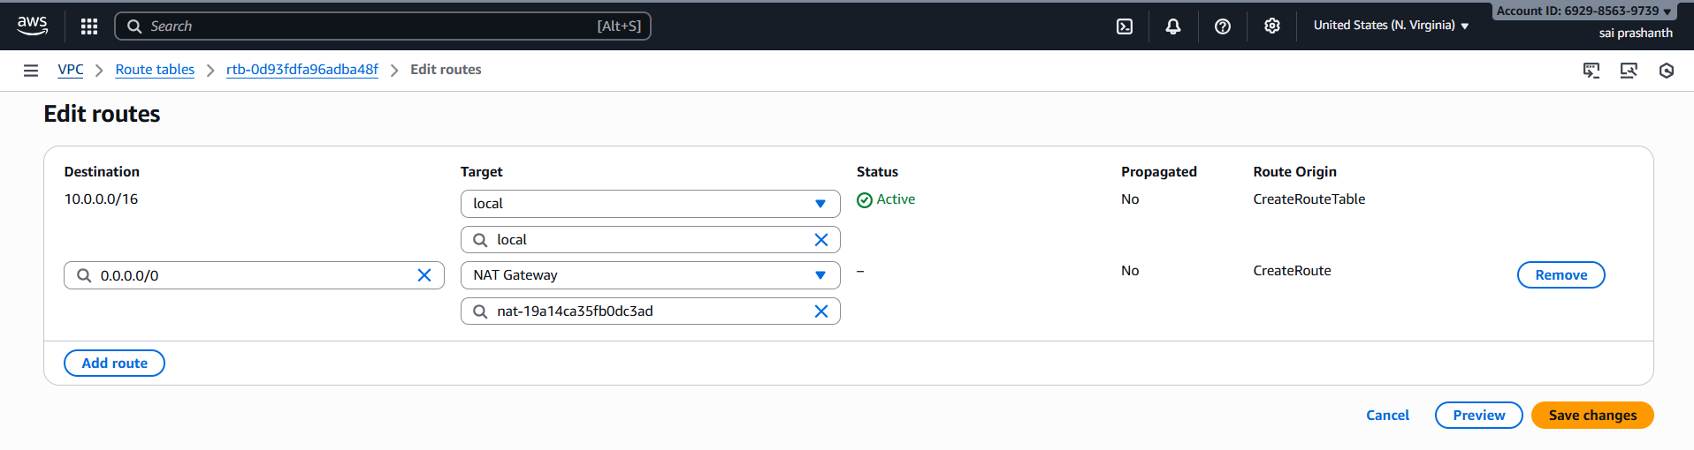

**validation steps** :

now you can see the nat gateway has been attached to private subnet

it has been deployed at public

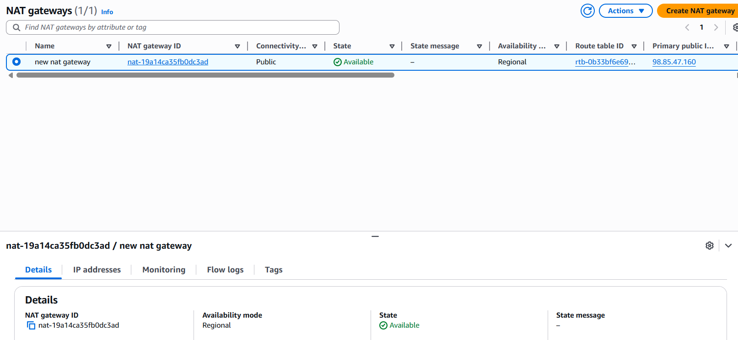

1. **title: Create two instances, one in the public subnet and one in the private subnet**.

**objective** : we need to create ywo instances one for public and one for private

**prerequisites**:

ec2

launch instance

type of intance

pem key

security groups

AMI

**step by step process :**

first we need to launch an instance by clicking on launch instance—ami—keypair—selecting vpc—for for public subnet and another for private subnet

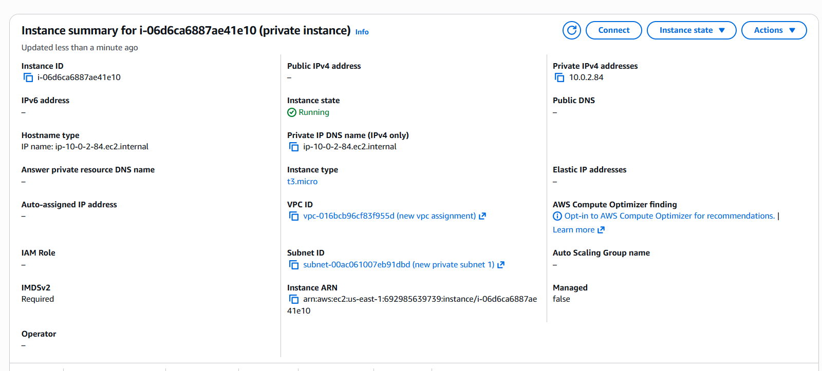

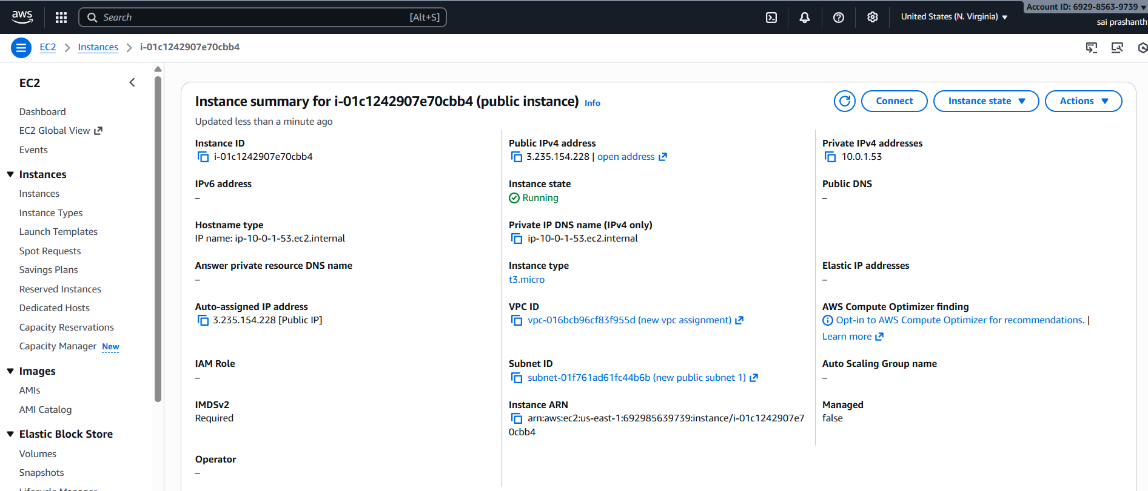

**validation steps :**

now you can see both instances has been created

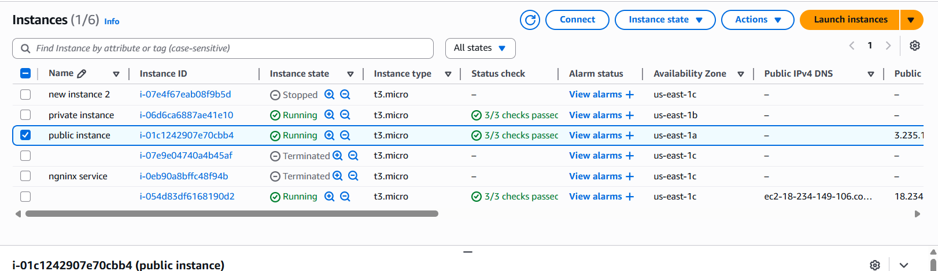

1. **title: Deploy Apache server on both EC2 instances with a sample index.html file**

objective : now we need to create one httpd pr Apache server in both instances with sample index.html file

**prerequisites**:

Apache script

enabling security groups

allowing permission ssh and httpd for both public and private

**step by step process:**

while launching instance we need to add user data

**#!/bin/bash**

**sudo dnf update -y**

**sudo dnf install httpd -y**

**echo "Hello from $(hostname)" > /var/www/html/index.html**

**sudo systemctl enable httpd**

**sudo systemctl start httpd**

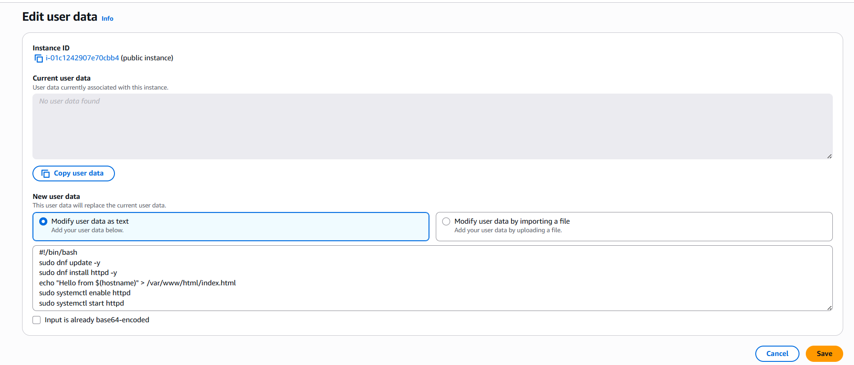

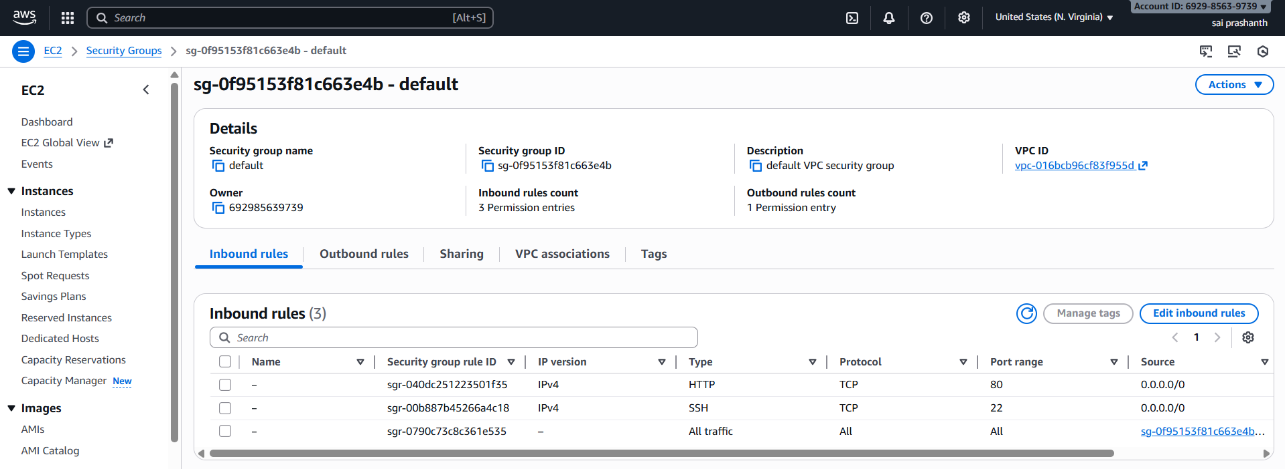

now we need to download the sample file or you can use existing index.html file

here I used existing file

now connecting through public instance

copy the public ip and run with port number 80 as it is httpd

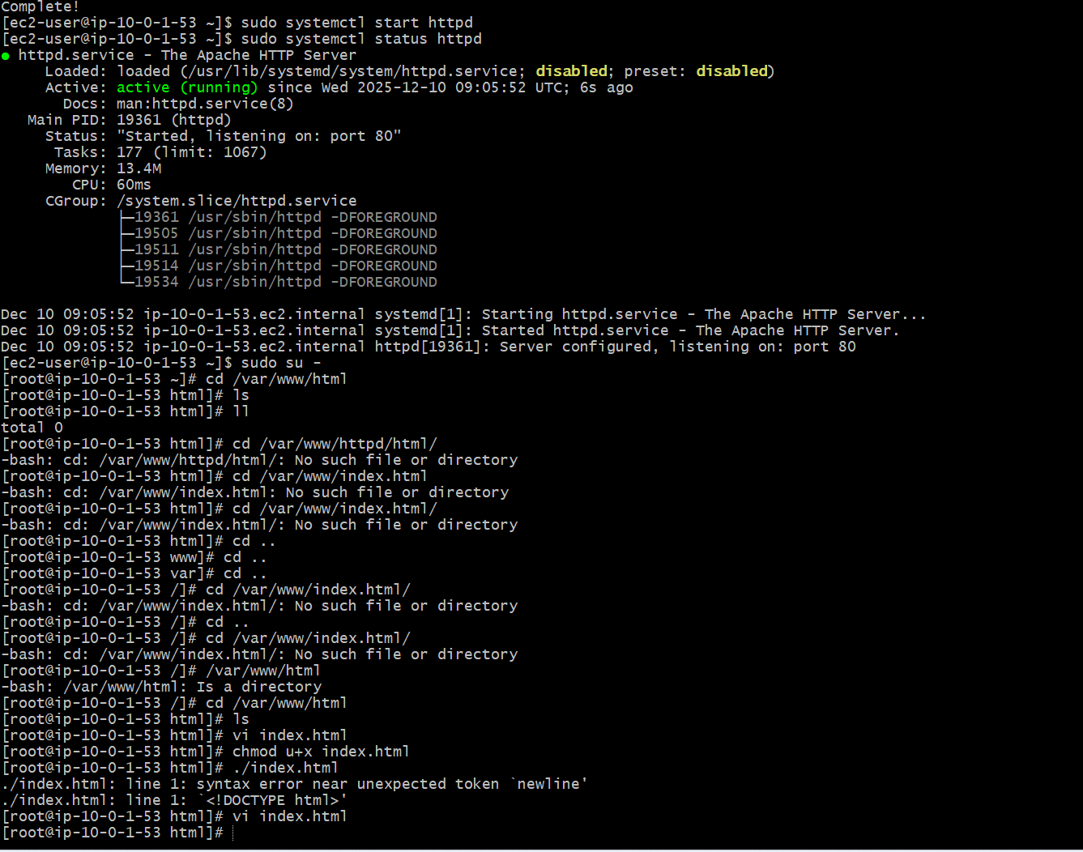

validation steps: I have run this using public ip and port number 80

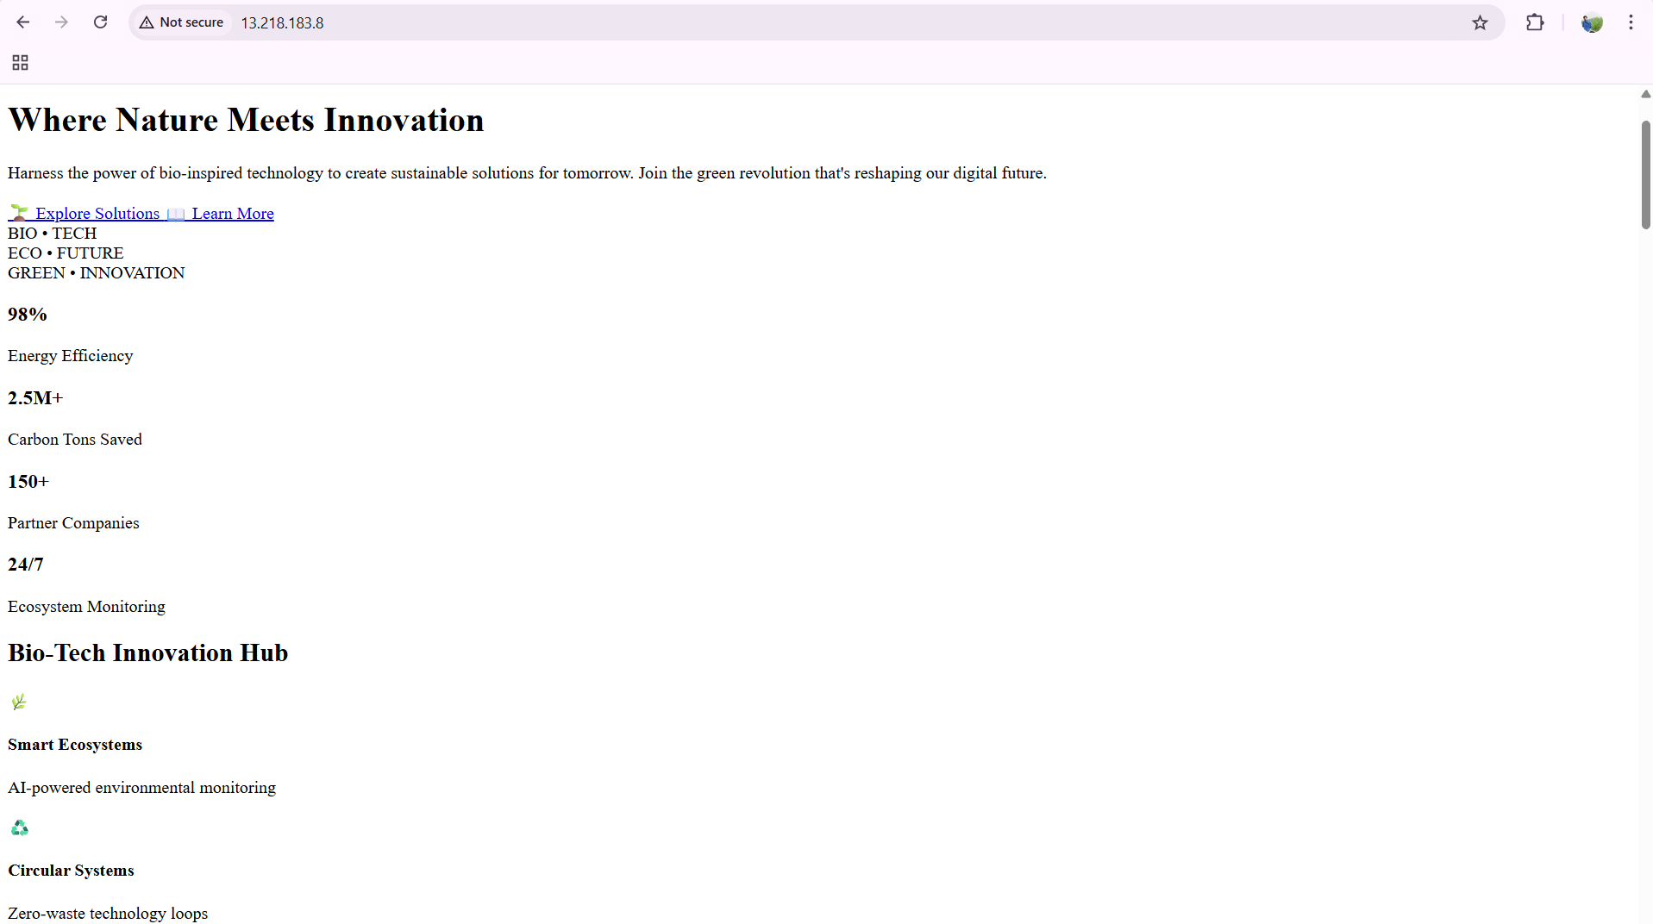

now to connect to private ec2 we are using jump server

first go to your pem key from downloads and open with note pad

copy the authorized content and paste it in create one smaple pem called test.pem

vi test.pem and paste the content

then the process same as follow

once restart the service

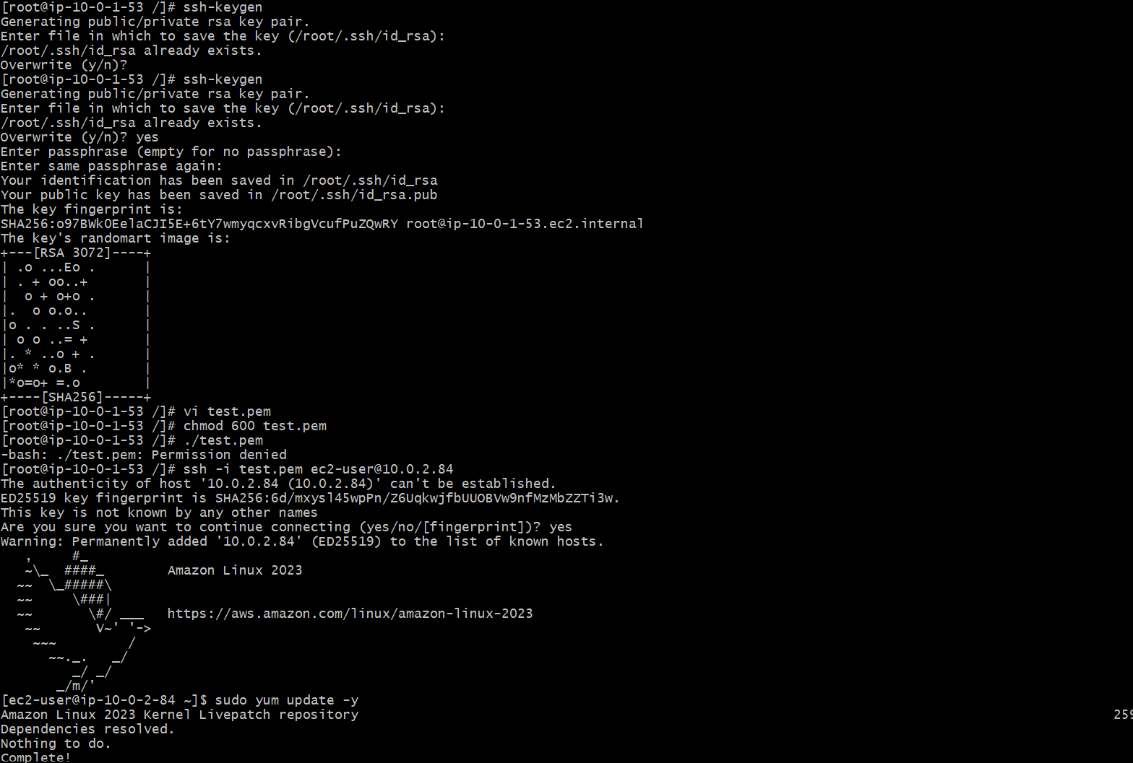

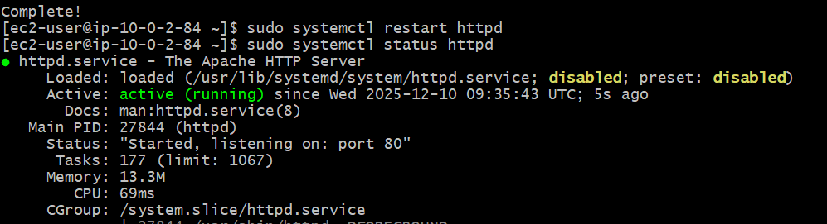

we need to do index.html by switching to root user

and we need to use curl <http://privateip>

why we need to use curl because to check the remote connectivity

**validation steps:**

**now you can see the output by using curl**

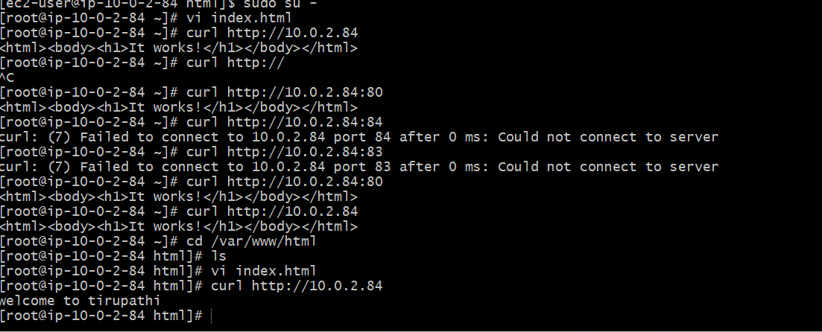

1. **title: Create one application load balancer and attach it to both EC2 instances.**

**objective**: we need to create one load balancer and we need to attach both ec2 instances

**prerequisites**:

ec2

load balamcer

security group

asg

health check

target groups

**step by step process:**

ec2console—select target groups first

we need t create target groups

target type—instance

give any target group name

select protocol http and 80 port

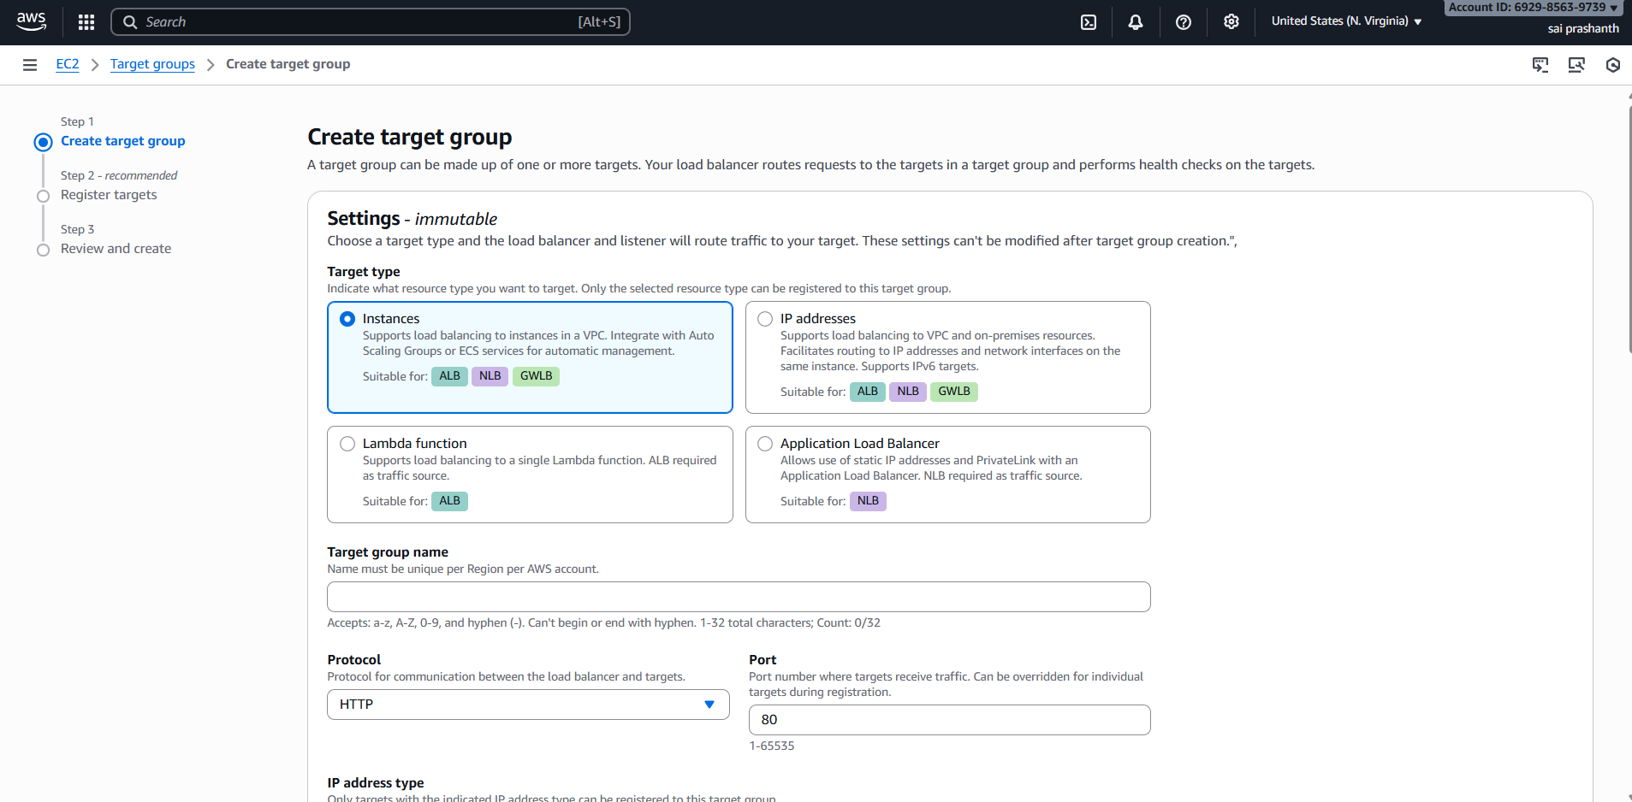

now we need to register the targets-- select your both instances—ports 80 for both and click on include as pending below

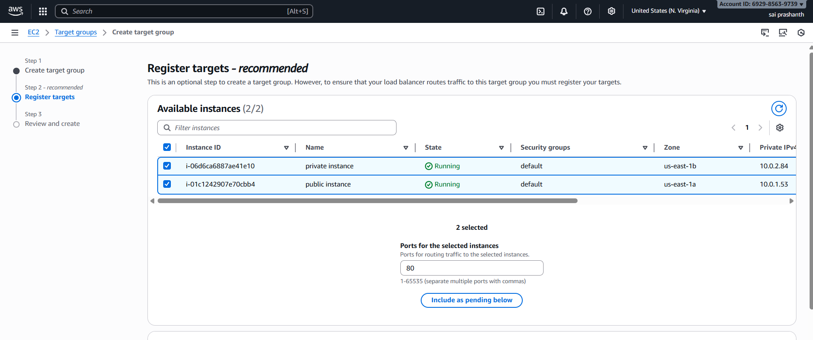

now we need to review and create target groups

now the target groups has been created

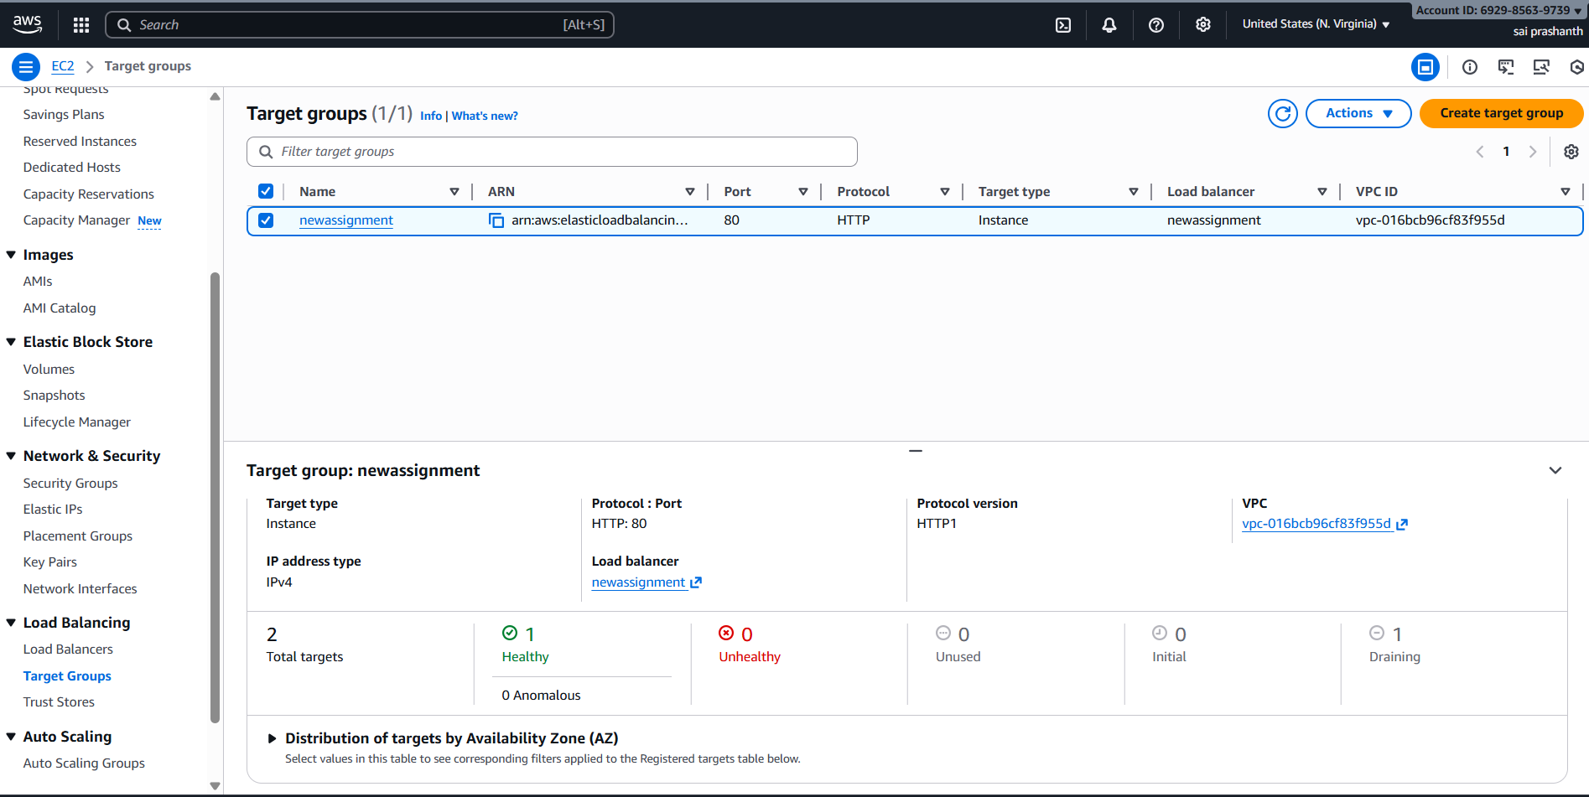

ensure it should be healthy both

then only you can run the two instances both public and private

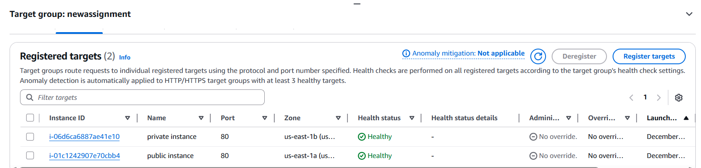

if your private instance shows health status as fail or unused you need to change the configuration in security groups

allow again http with what you have created security group while creating target groups

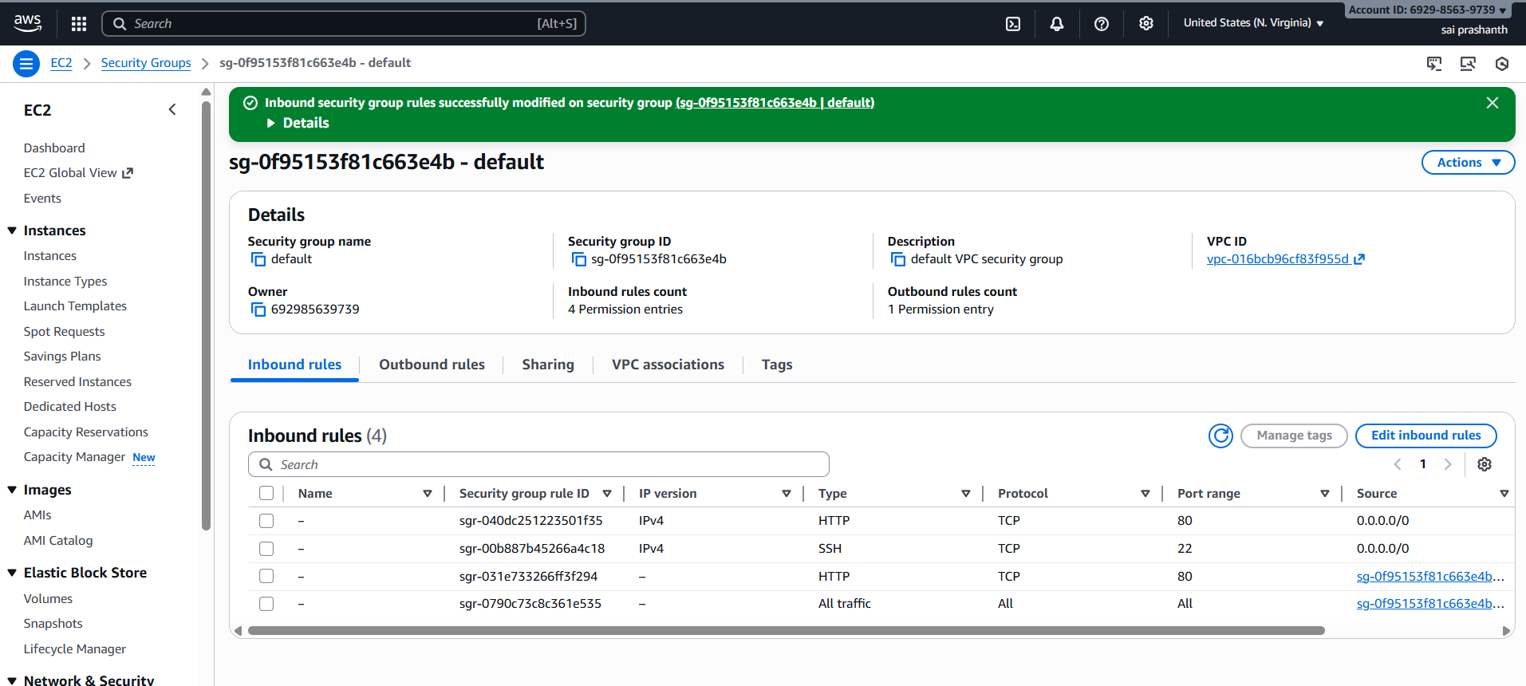

now come to load balancer

click on create load balancer—select applicaion load balancer

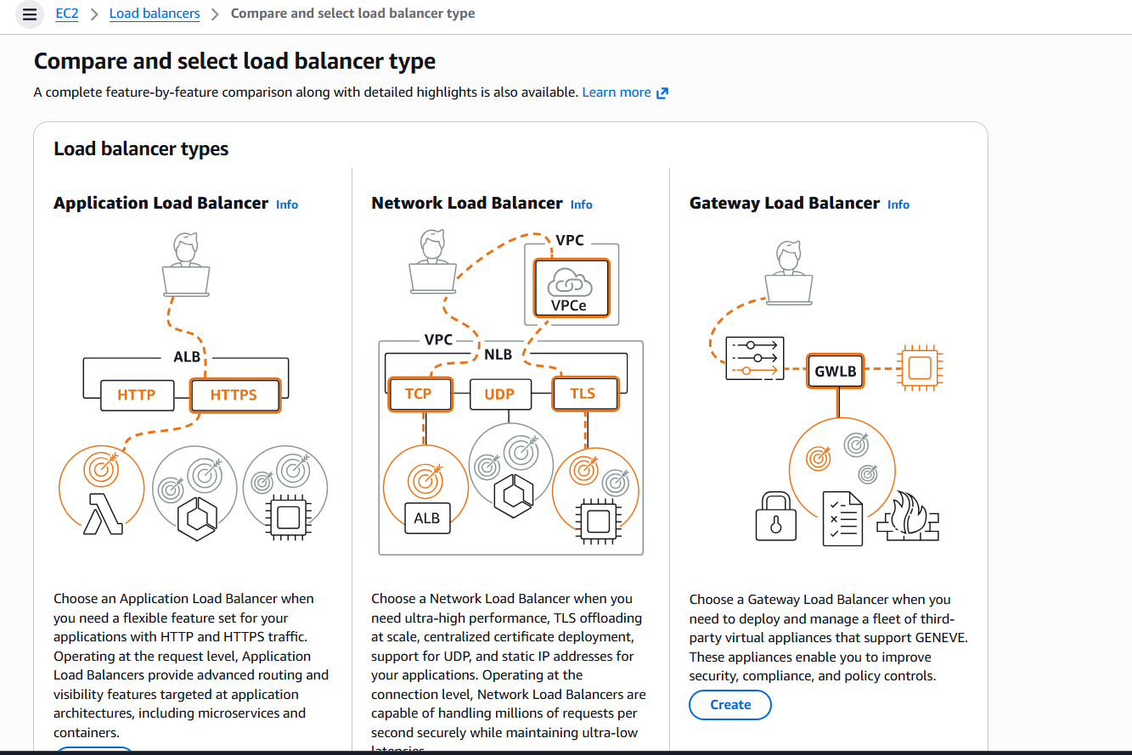

now provide the details

load balancer name—scheme internet facing—select vpc—availability zone—ip address type -ipv4

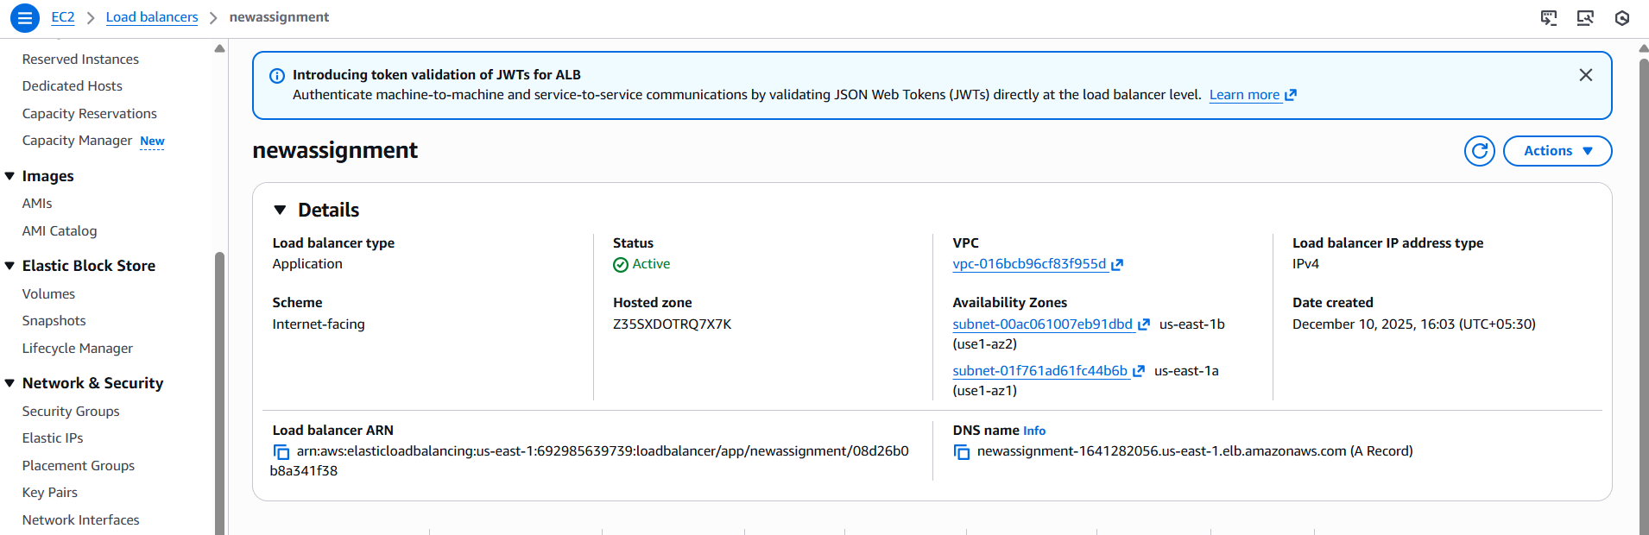

now register the targets ---here I selected both instances

after that click on create load balancer

now you can see the load balancer has been successfully created

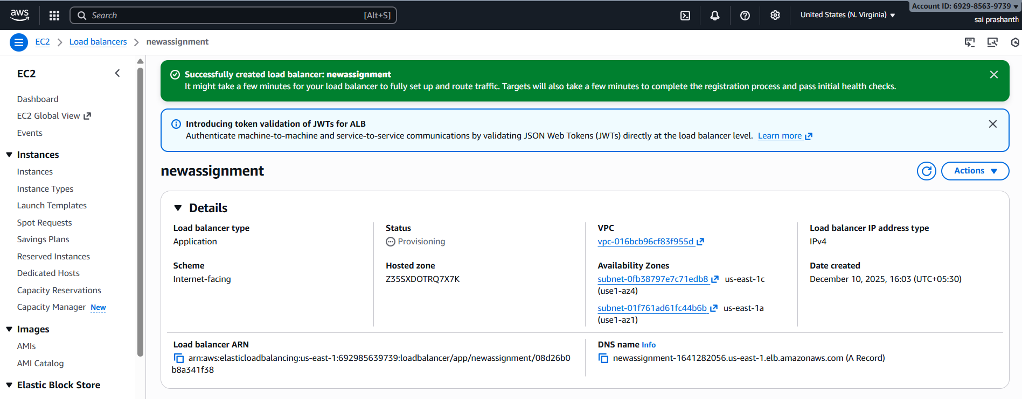

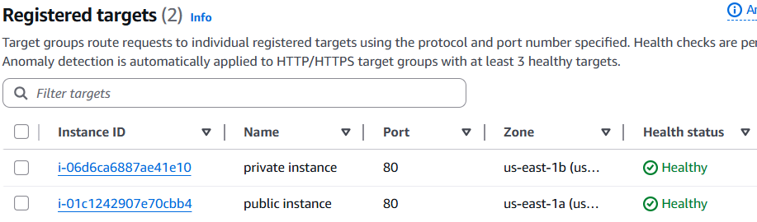

**validation steps:**

now to verify with load balancer dns name

go to browser and check with one after one

this is used for public instance index html



now afetr doing refresh

this is used private instance index html



**conclusion**: now we have executed load balancer with two intances private and public with private subnet and public subnet .

1. **title: Store application load balancer logs in S3.**

**objective:** we need to store the load balancer logs in service S3

**prerequisites**:

load balancer

s3 bucket

bucket policy

**step by step process :**

first we need to create one s3 bucket to store the logs

provide the bucket name and eneble public access

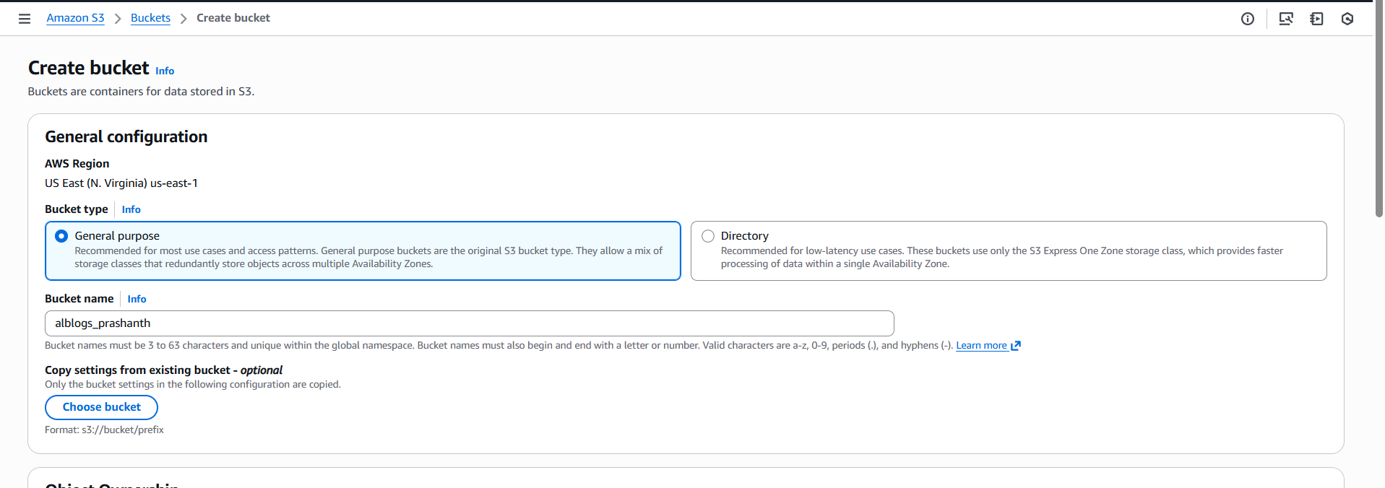

now the bucket has been creasted

here I created name with alblogs-prashanth

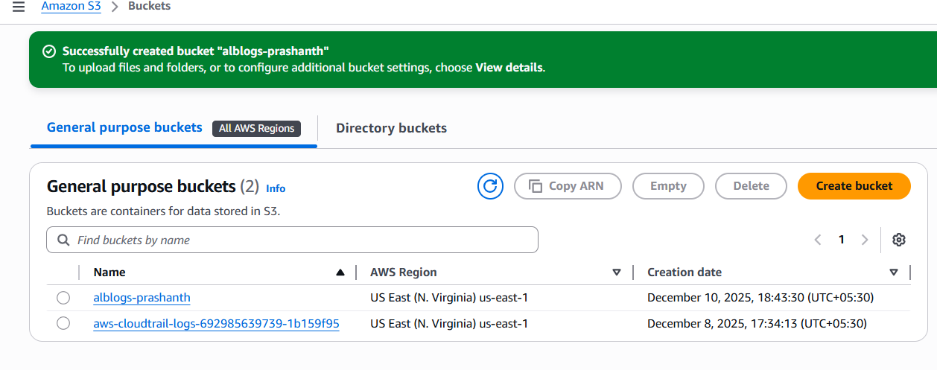

now we neef to create one bucket policy

select your bucket—go to permissions—edit on bucket policy

afetr entering the content—edit your arn bucket id and account id

{

"Version": "2012-10-17",

"Statement": [

{

"Sid": "AllowALBLogs",

"Effect": "Allow",

"Principal": {

"Service": "logdelivery.elasticloadbalancing.amazonaws.com"

},

"Action": "s3:PutObject",

"Resource": "arn:aws:s3:::YOUR-BUCKET-NAME/AWSLogs/YOUR-AWS-ACCOUNT-ID/*",

"Condition": {

"StringEquals": {

"s3:x-amz-acl": "bucket-owner-full-control"

}

}

},

{

"Sid": "AllowALBLogBucketAccess",

"Effect": "Allow",

"Principal": {

"Service": "logdelivery.elasticloadbalancing.amazonaws.com"

},

"Action": "s3:GetBucketAcl",

"Resource": "arn:aws:s3:::YOUR-BUCKET-NAME"

}

]

}

and click on save

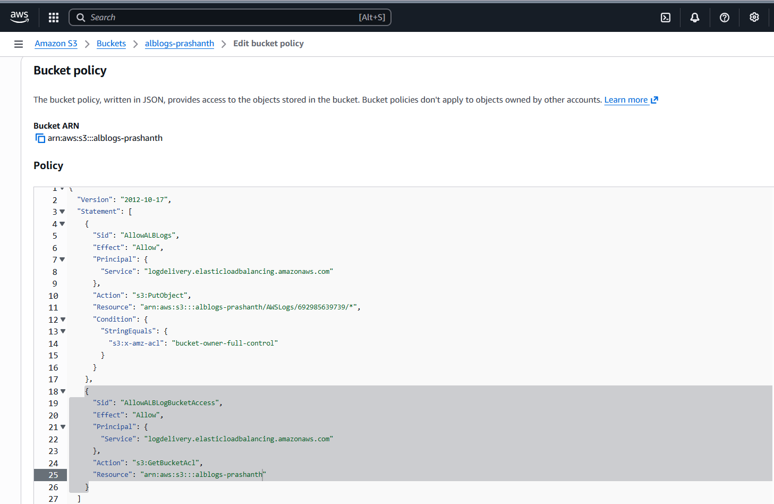

now go to load balancer—attributes—click on edit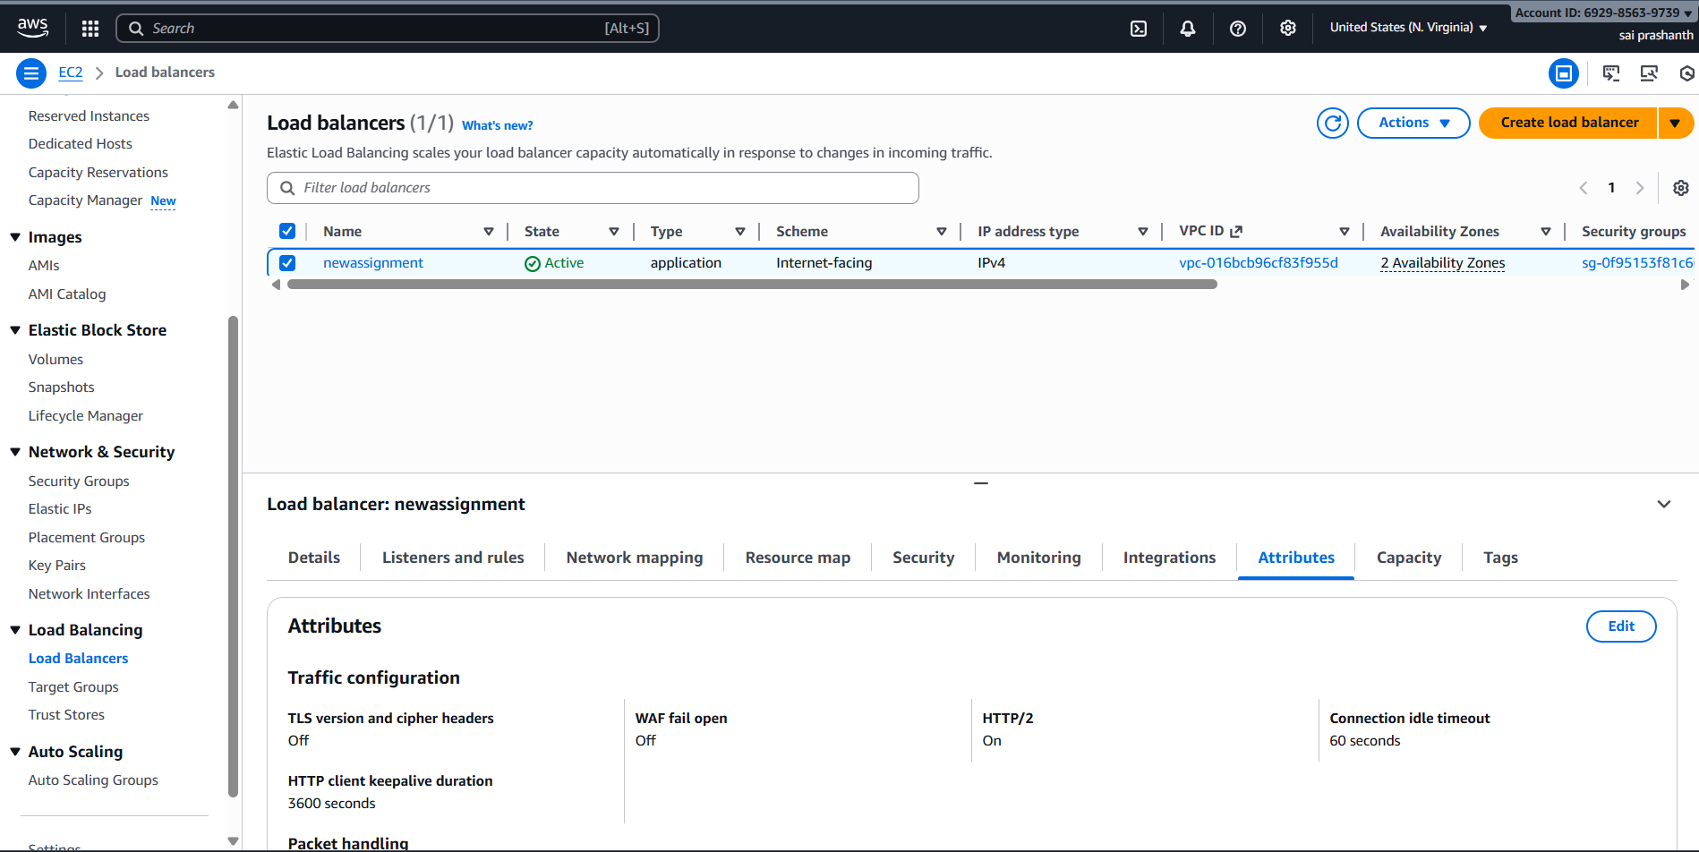

now enable access logs in monitoring

and select your s3 bucket by clicking on browse s3

and click on save changes

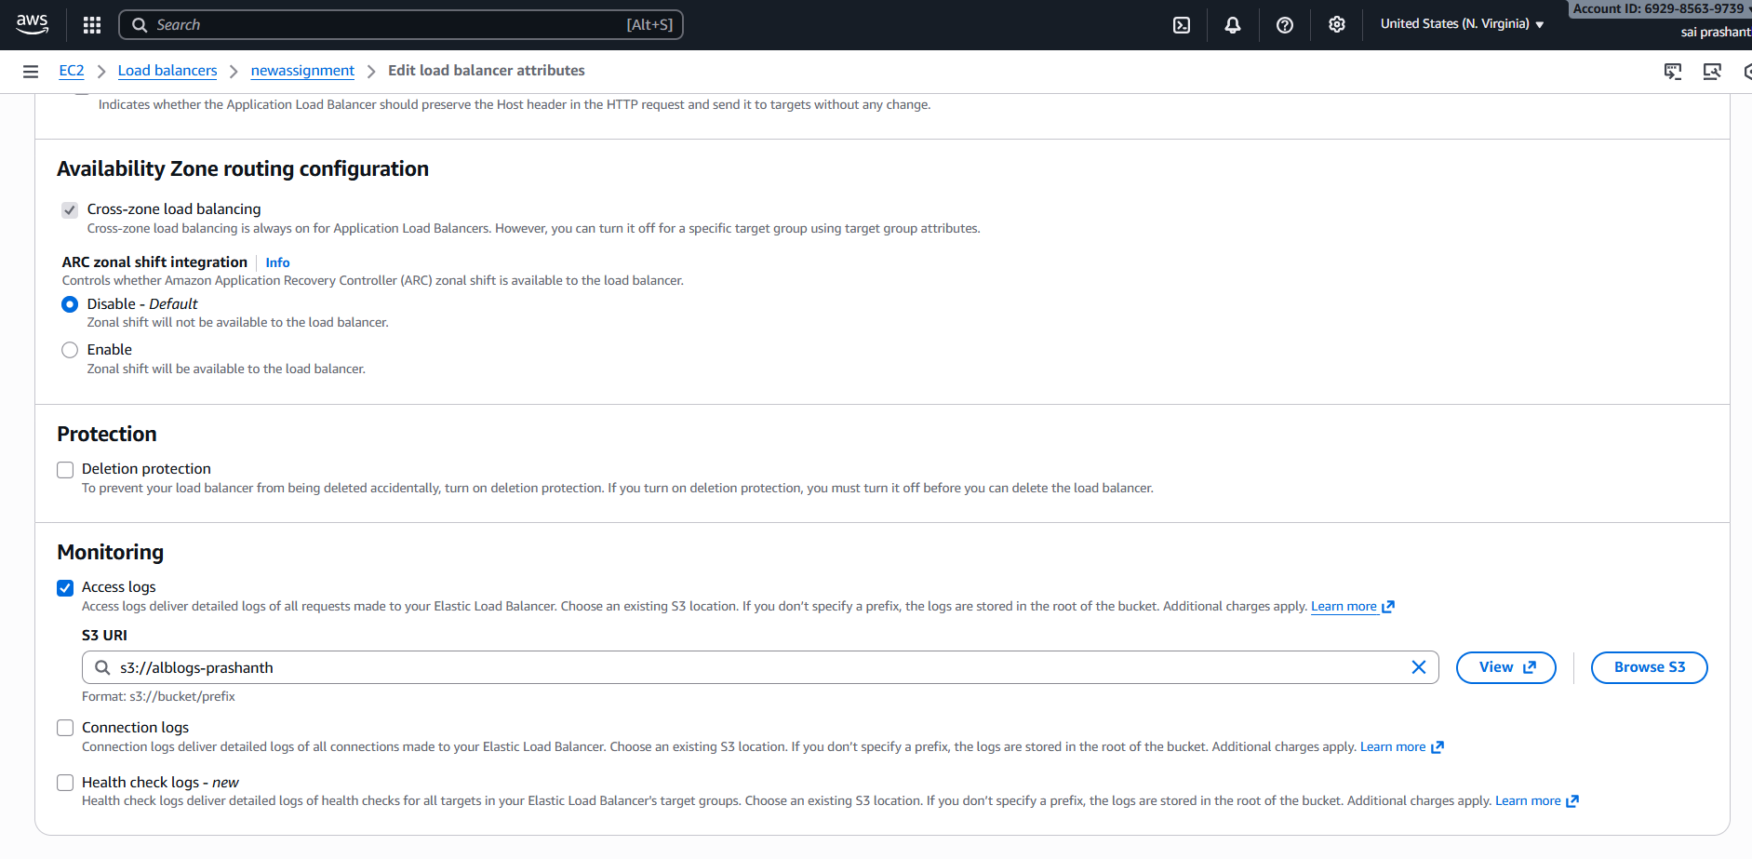

now you can see attributes has been created successfully

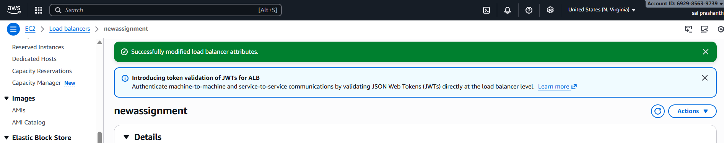

now again switch to S3—select your bucket

wait for 2 minutes to get the logs intyo your bucket

now keep on clicking the objects

it tajkes some time to get the logs

validation steps: now you can see the alb logs in S3

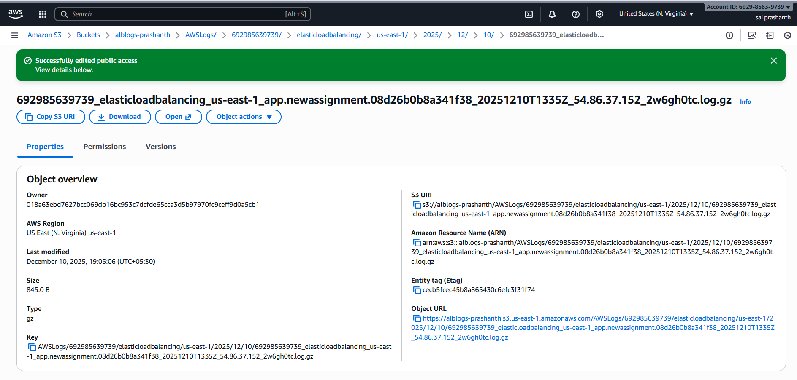

in load balancer also you can check where it has been stored

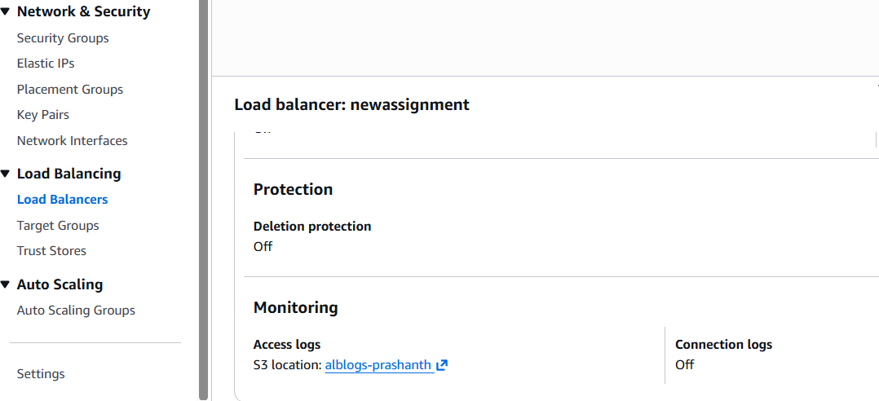

**conclusion** :this is the process of storing the ALB logs in S3

1. **title:Store the VPC flow logs in a CloudWatch log group.**

**objective :** we need to stpre vpc flow logs in cloudwatch log

**prerequisites**:

vpc

flowlogs

cloudwatch log group

**step by step process:**

first go to your vpc console

--click on create flowlogs

--then provide flowlog name

--filter-all

--maximum aggregation interval—1 minute

--destination –send to cloud watch

--destination log group name—create any

--service access—create and use a new service role

--it suggested one name automatically

--log record format—aws format

--now filally click on create flowlog

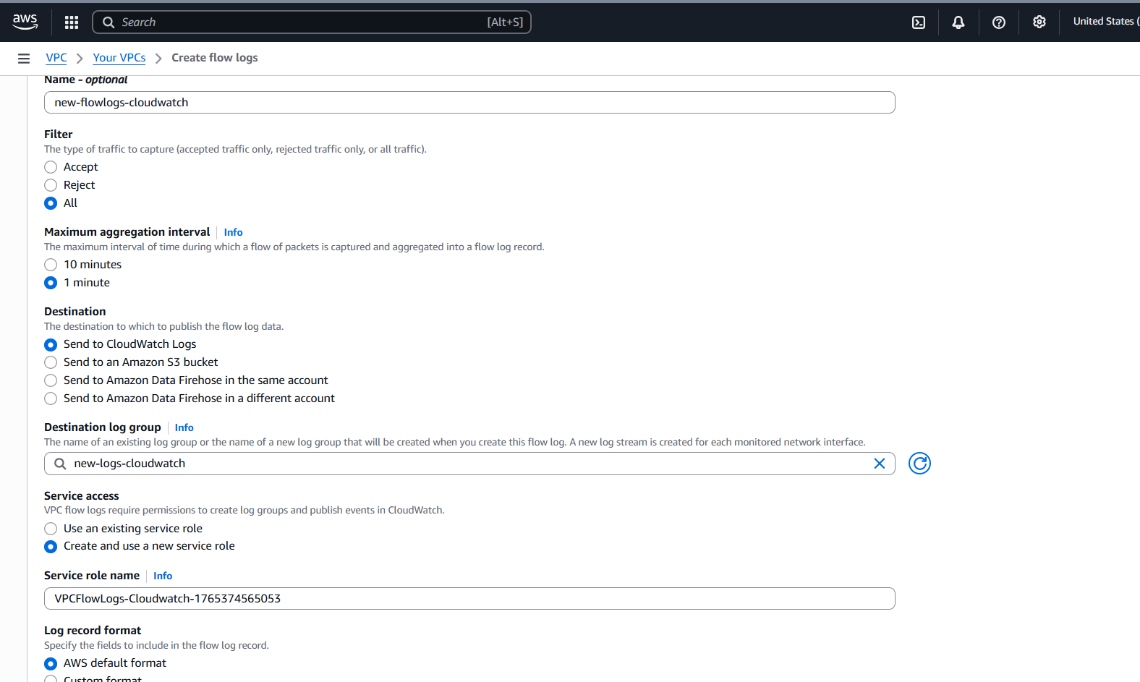

now you can see flowlogs in your vpc

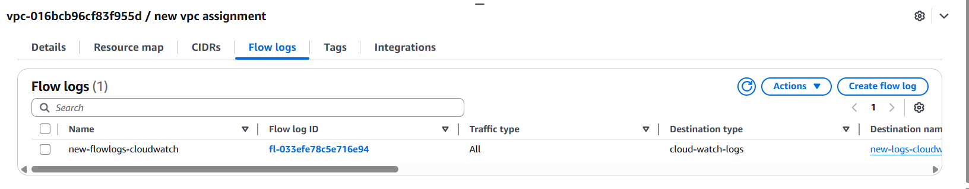

now go to cloud watch—log management—you can see the log file name

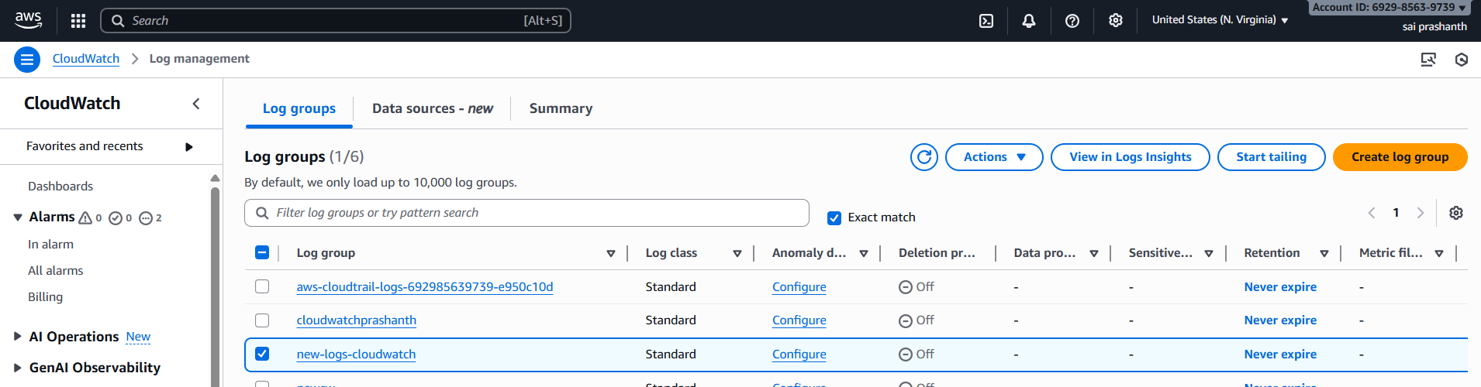

now click on it and select any of the log stream

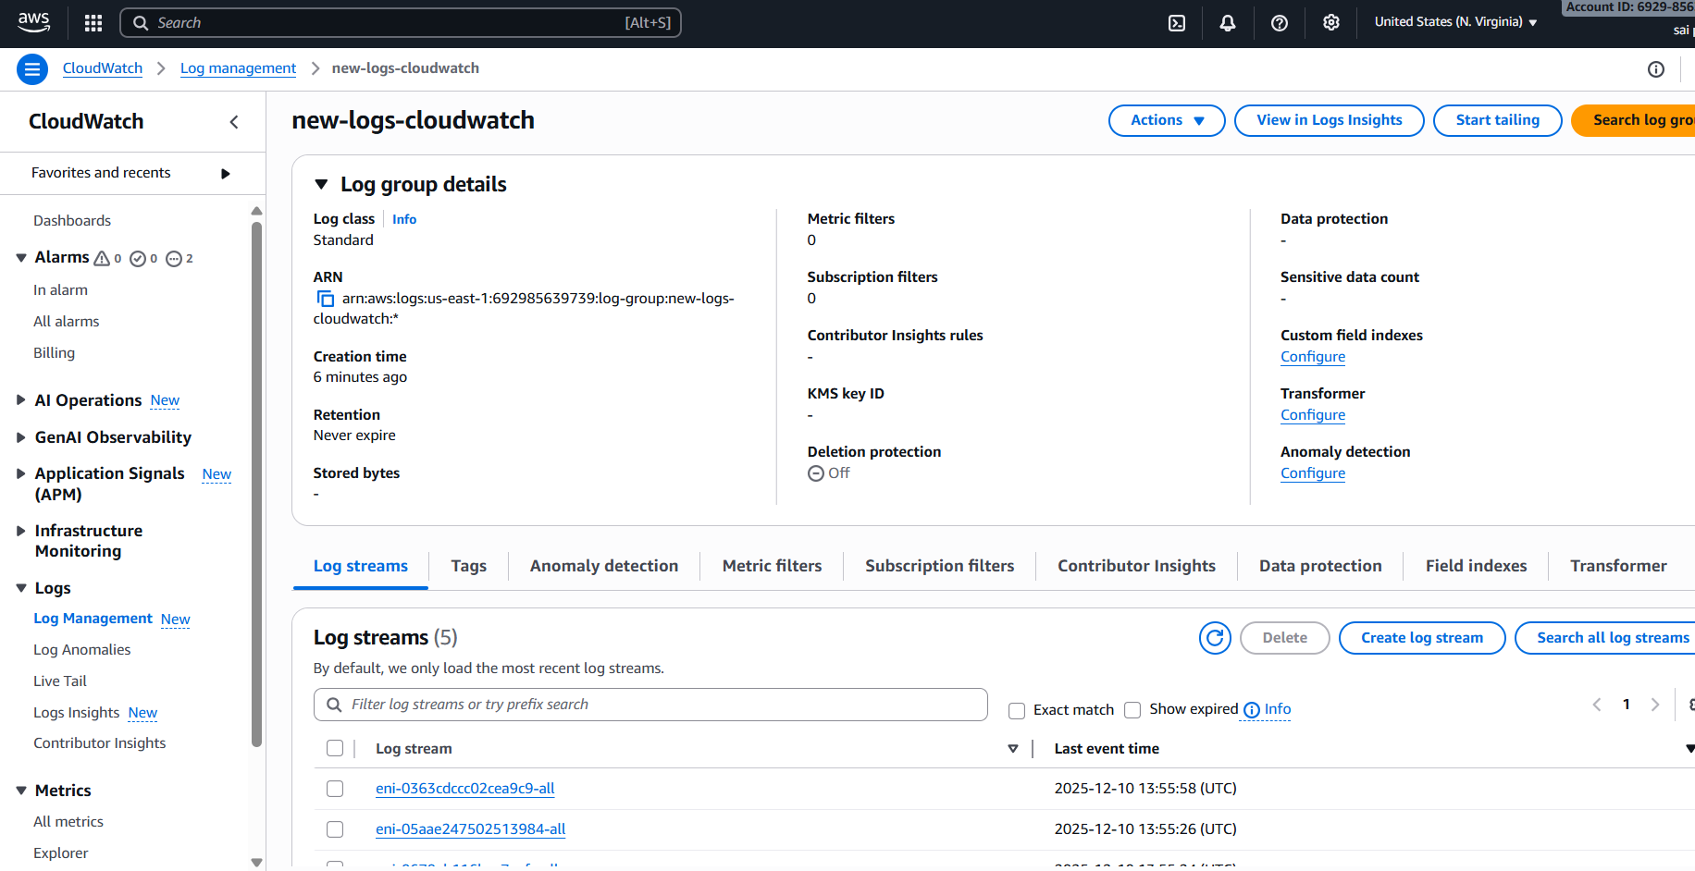

validation steps: now clicking anyone of the logstream you can logs running in cloudwatch

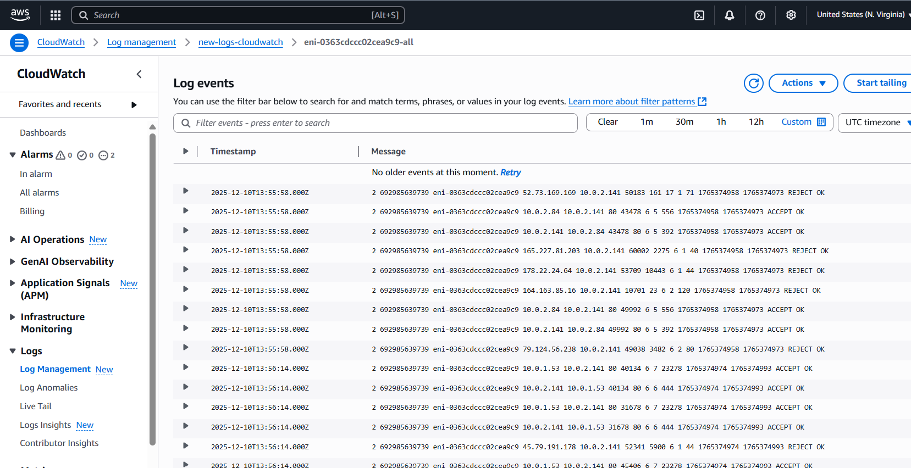

1. **title :Create monitoring dashboards to monitor CPU utilization and to monitor the Apache service.**

**objective :** we need to monitor cpu utilization and apache service

**prerequisites**:

cloudwatch

dash boards

cpu utilization

**step by step process :**

**go to cloud watch**

click on dashboard—create dashboard—provide any name—monitoringcpuutilization

click on next

select the metrix—select both private and public instances for cpu utilization

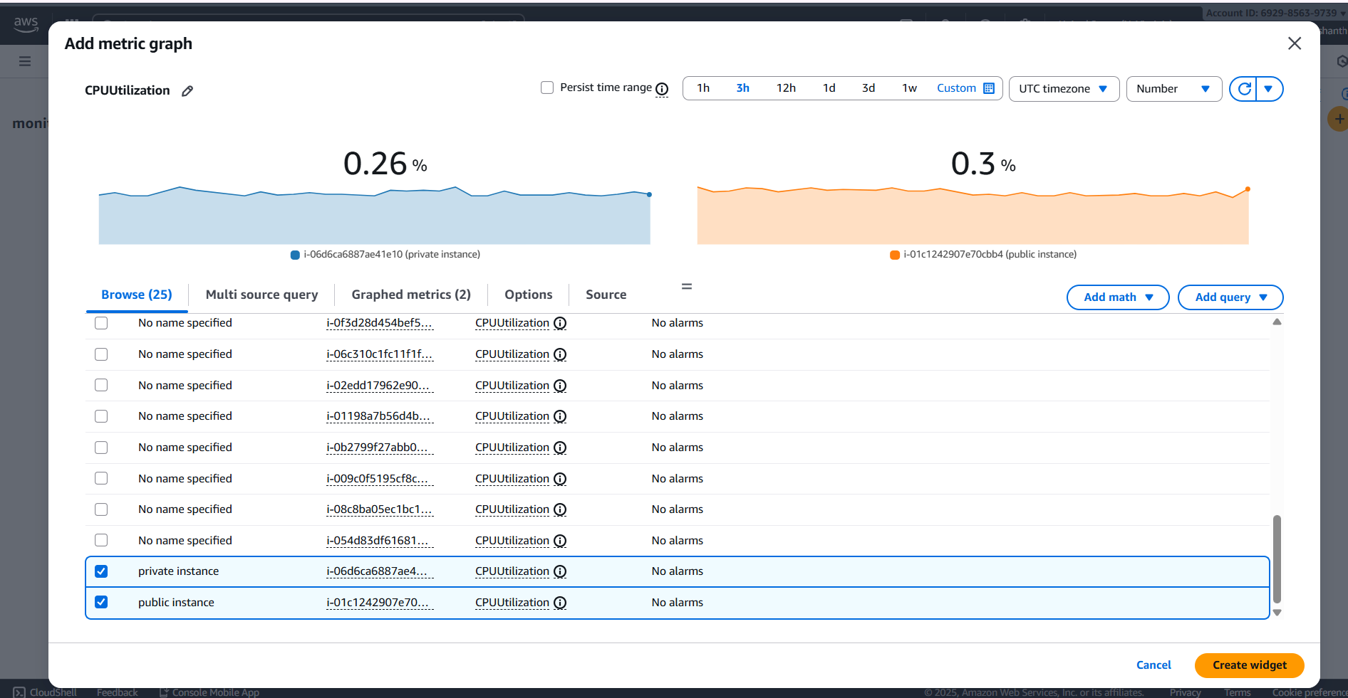

validation steps: created cpu monitoring

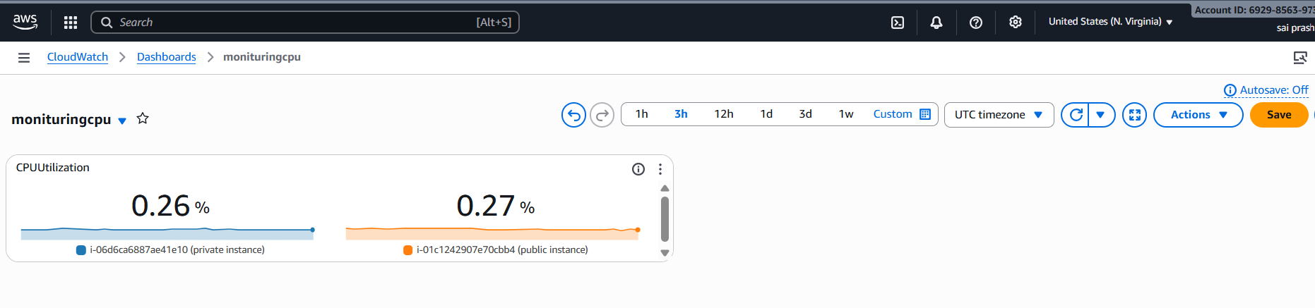

next step :

we need to create httpd monitoring now

first connect through instance

the check status of httpd

now create a script for running httpd and should display in metric in cloudwatch

create with vi /home/ec2-user/httpd_cloudwatch.sh

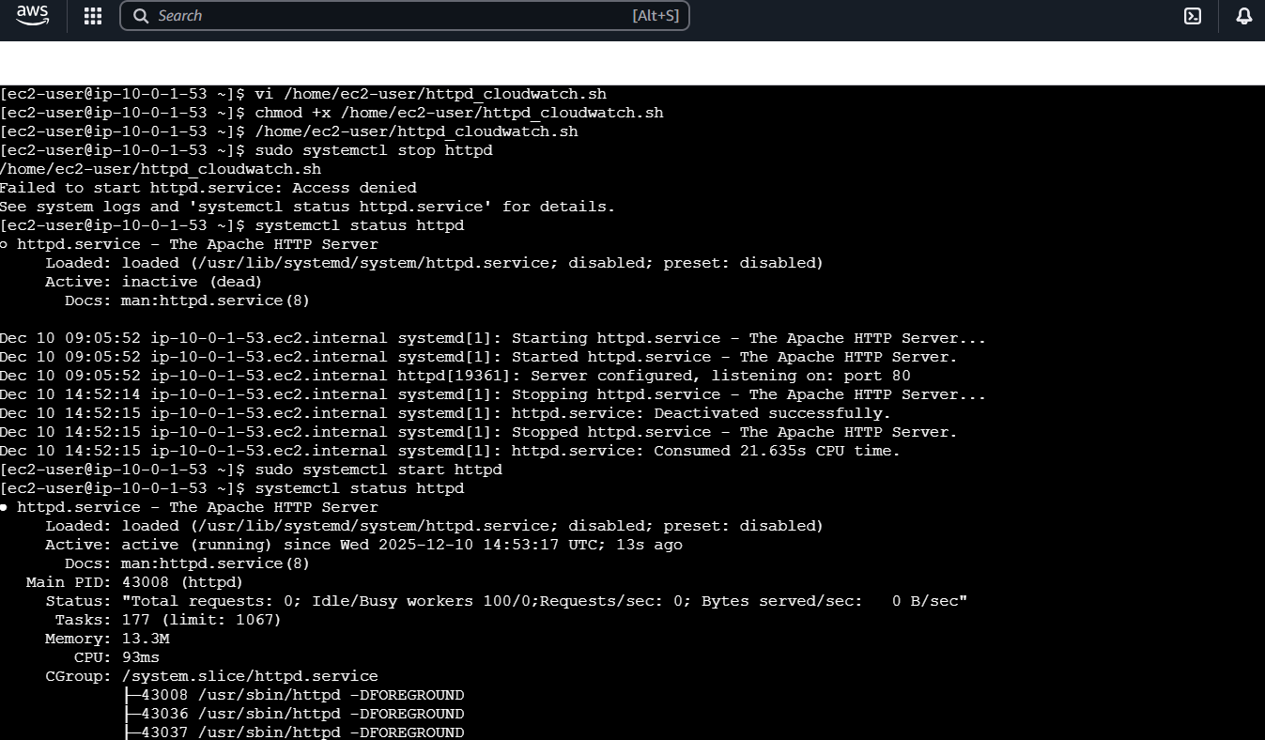

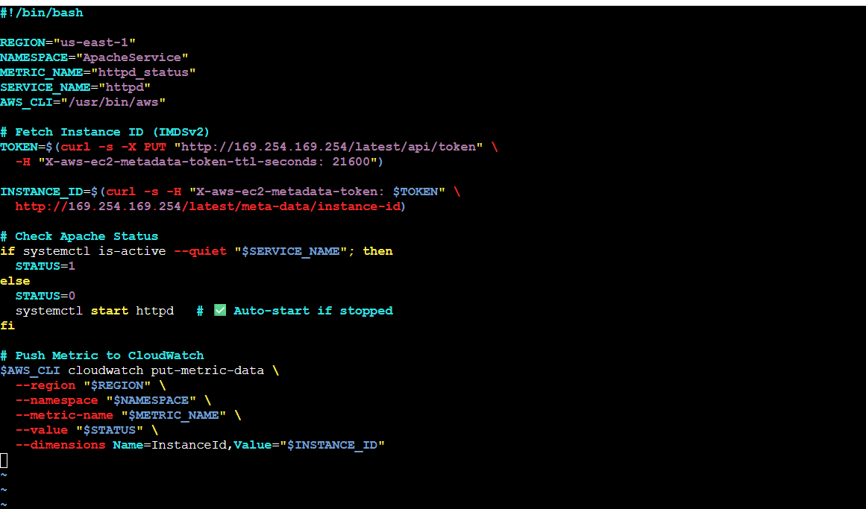

now give permissions and execute

now we need to provide crontab

to enable first we need to install sudo yum install cronie -y

enter cronjob in crontab -e

* * * * * /home/ec2-user/httpd_cloudwatch.sh >> /tmp/httpd.log 2>&1

now check status of crontab

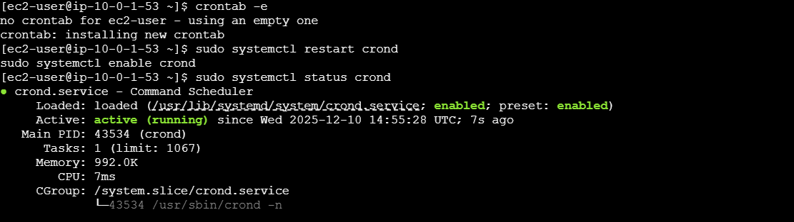

now go to cloudwatch—metrics—you can see apache service

click on that and create dashboard—widgets—dashboard name—and enable time for 1m

if it is getting 1 apache is running

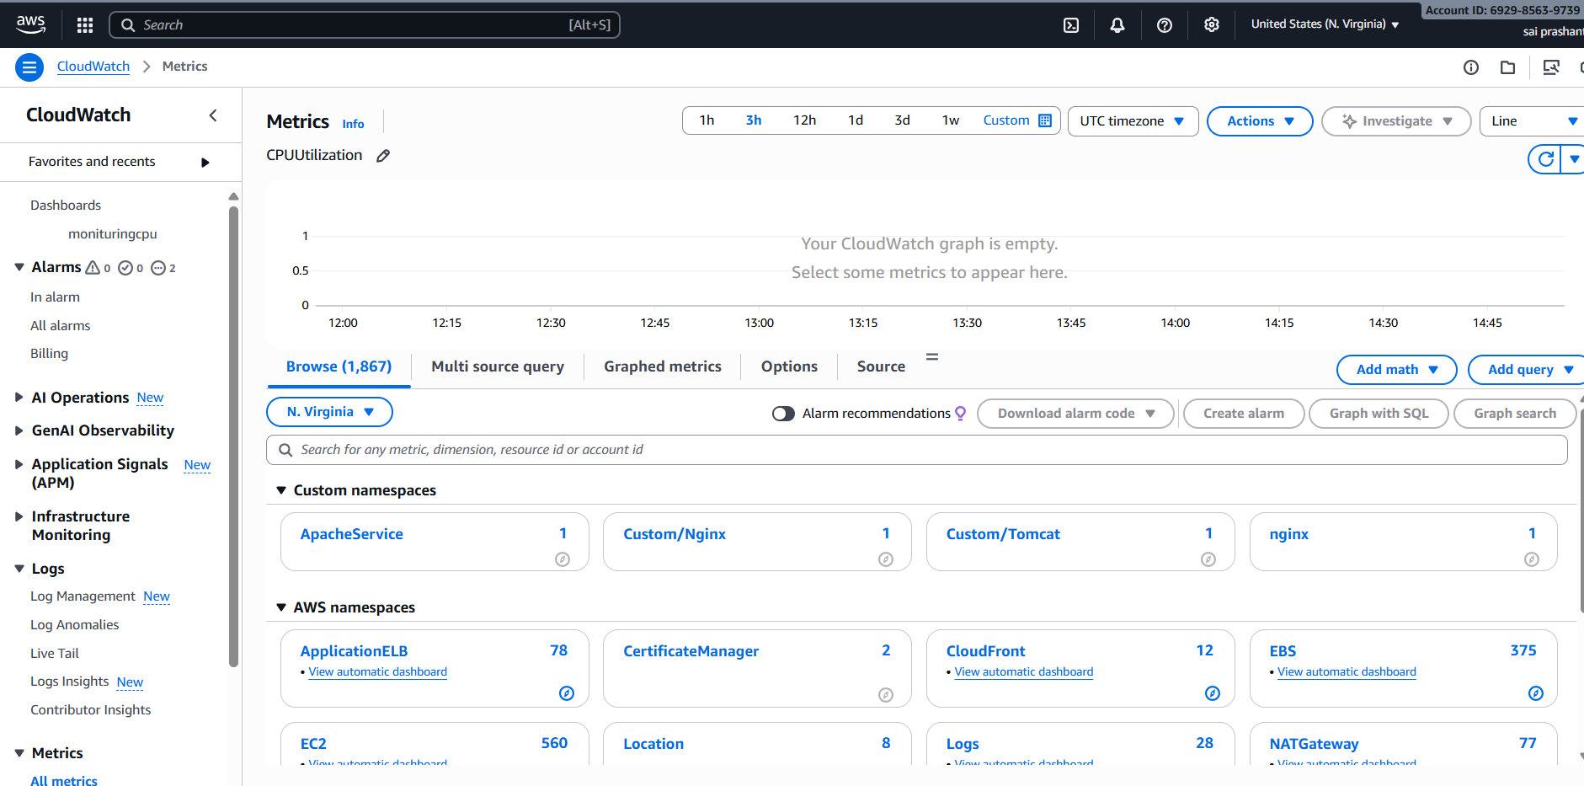

validation steps:

now you can see dashboard for apache or httpd status

it is 1 as it is running

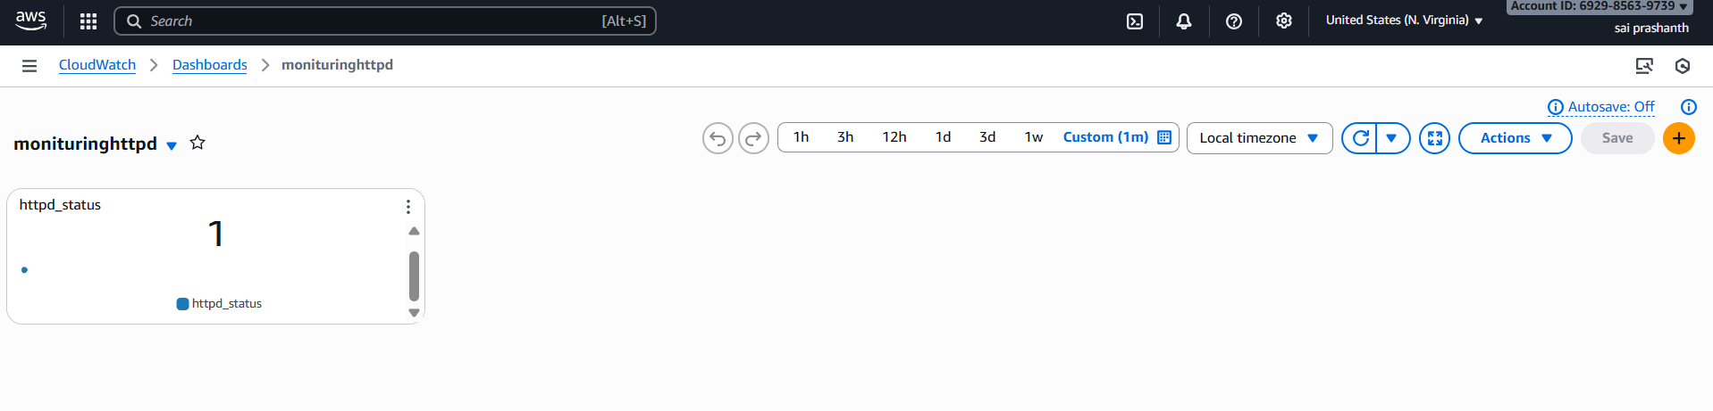

conclusion:

now you can see two dashboards

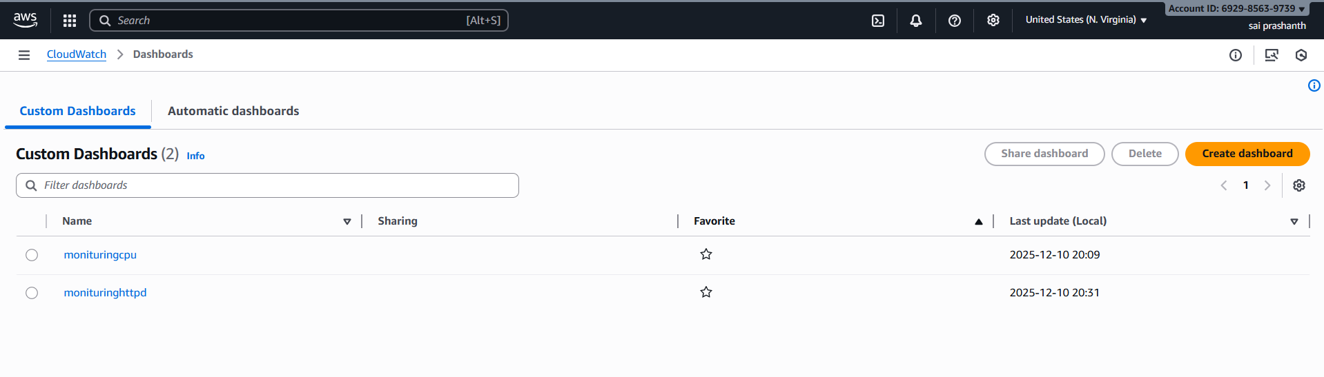  
**12. title:If CPU utilization is more than 70%, then it should trigger auto scaling and launch new instance.**

**objective :** if cpu is more than 70% it should reflect auto scaling and automatically launch one new instance

**prerequisites :**

auto scaling

launch instance

launch template

target groups

**step by step process:**

go to ec2 console—create launch template

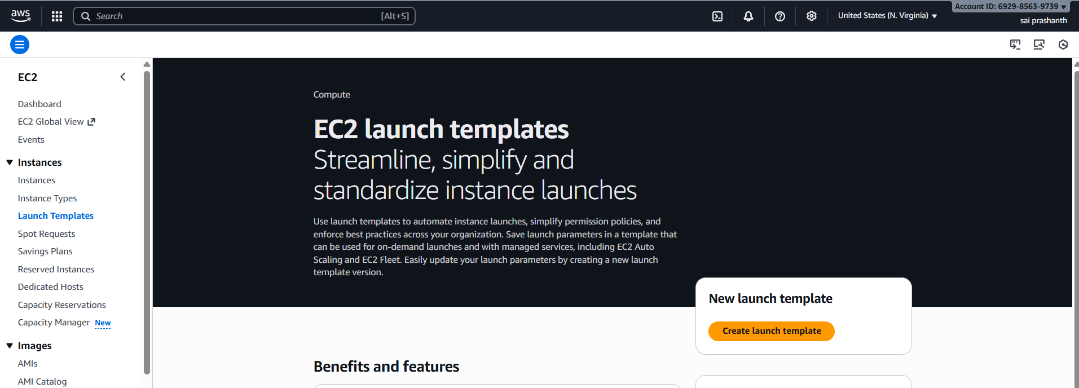

edit all the details template name, select the AMI,select your key pair and sg

and click on launch template

you can see now the template has been launched

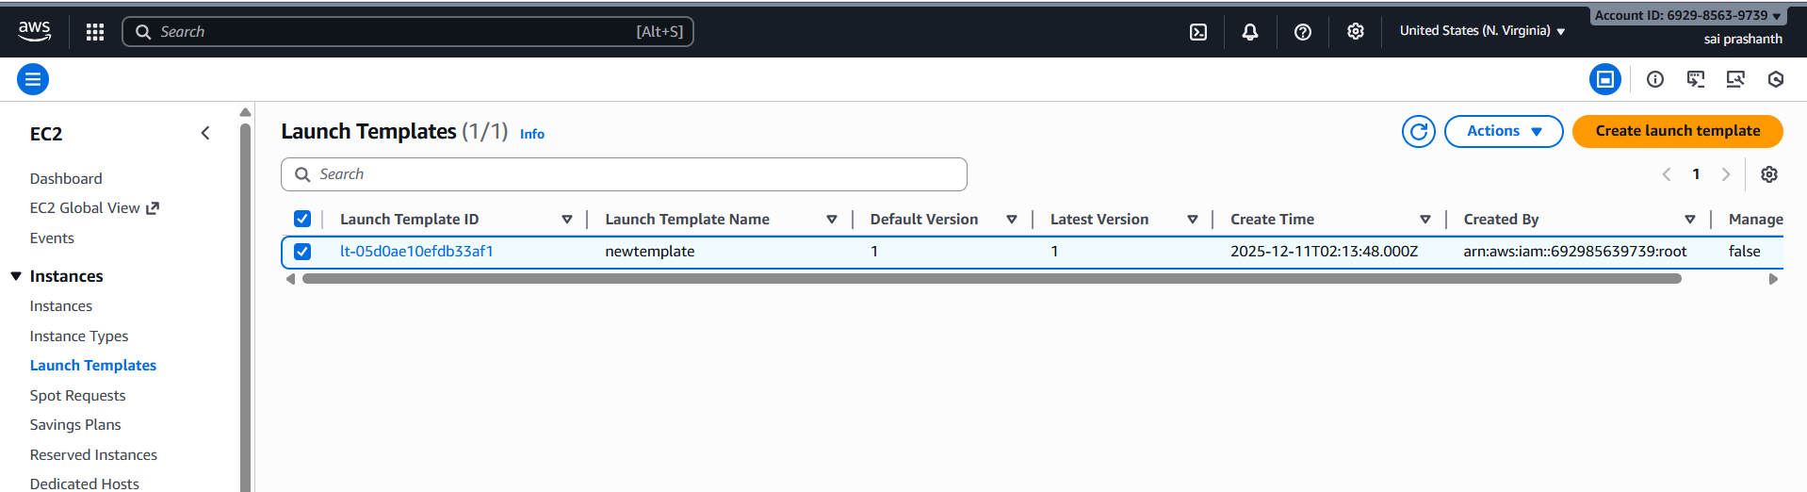

now we need to create auto scaling

go to ec2—click on auto scaling groups—create auto scaling groups—enter one name and select your template which you have created and click on next

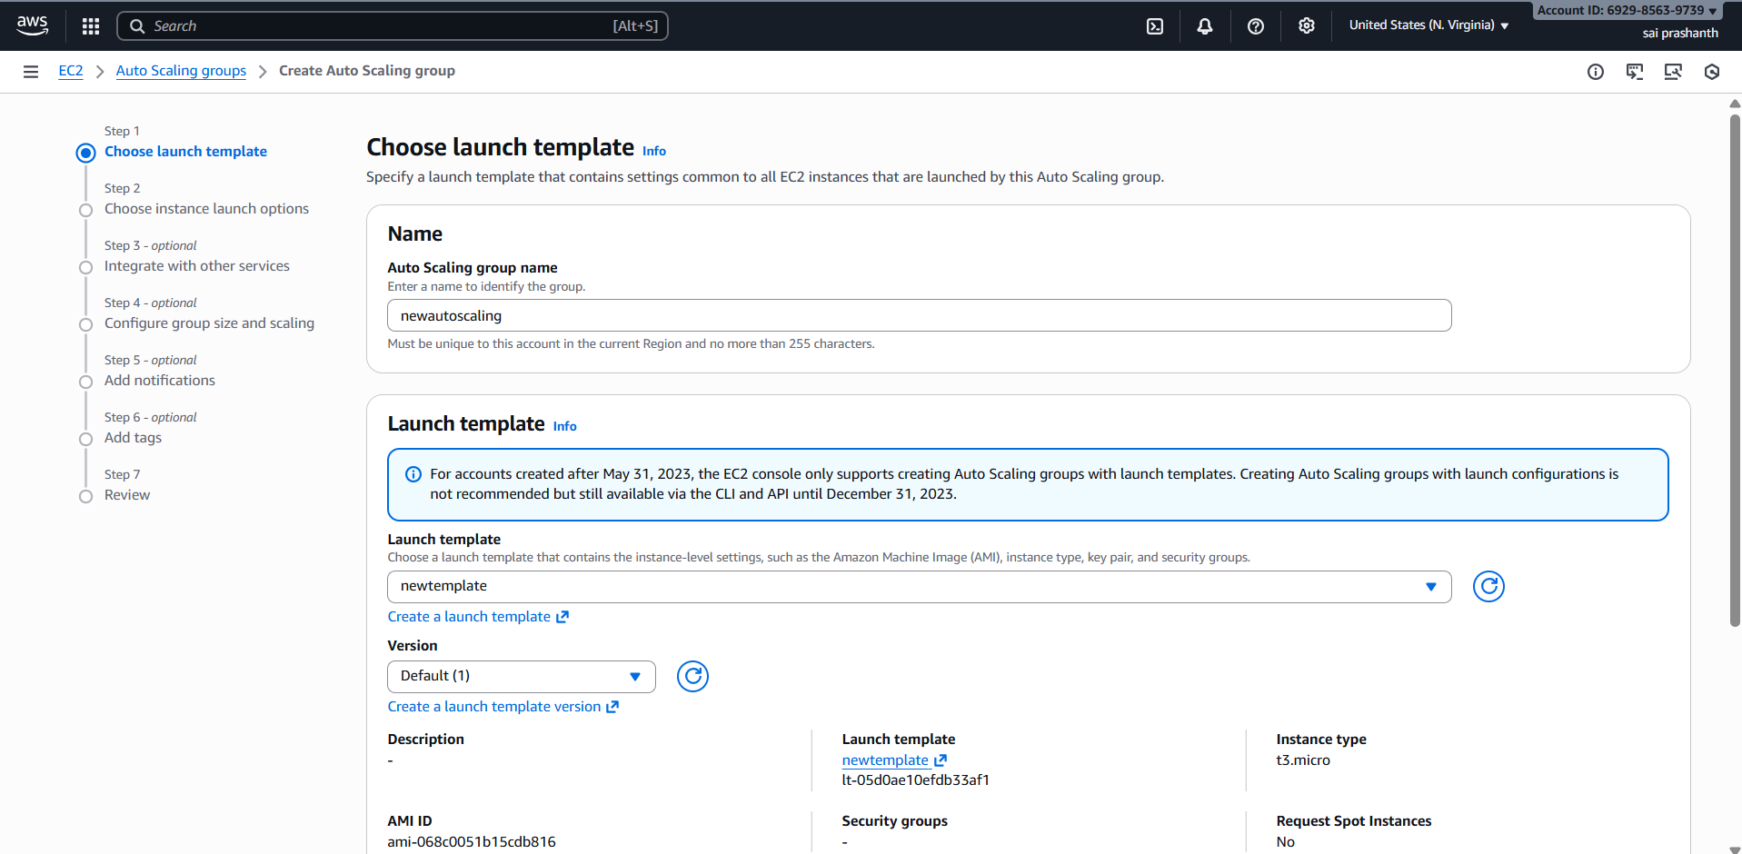

now seelct your vpc which you have created and subnets and click on next

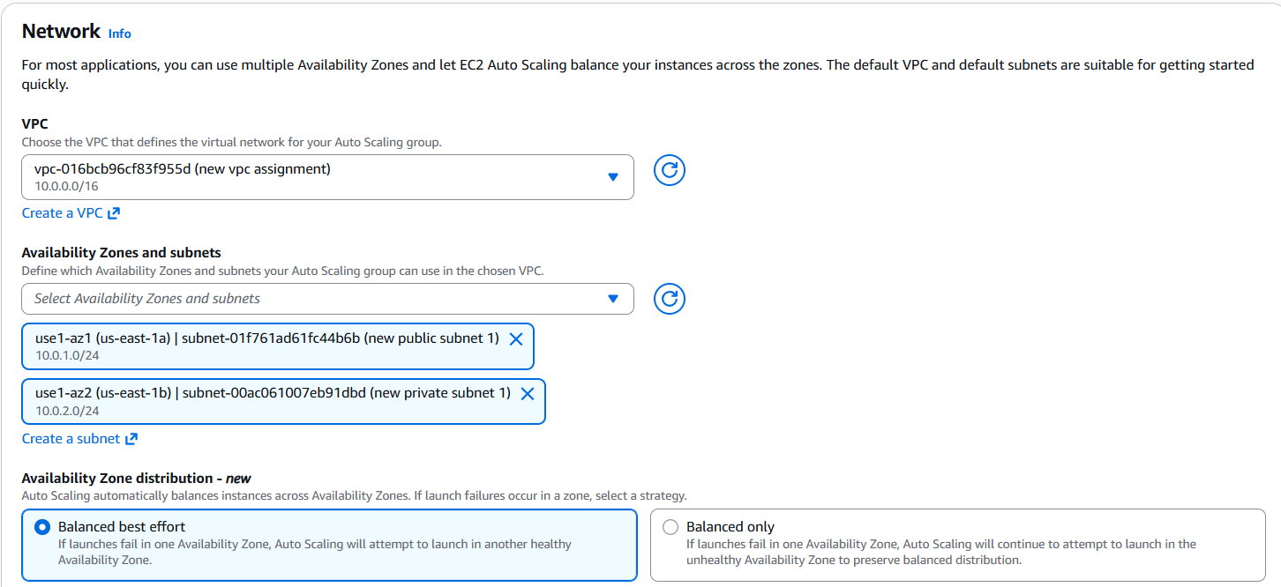

now we need to attach load balancer

select attach o exixting load balancer and choose yours and click on next

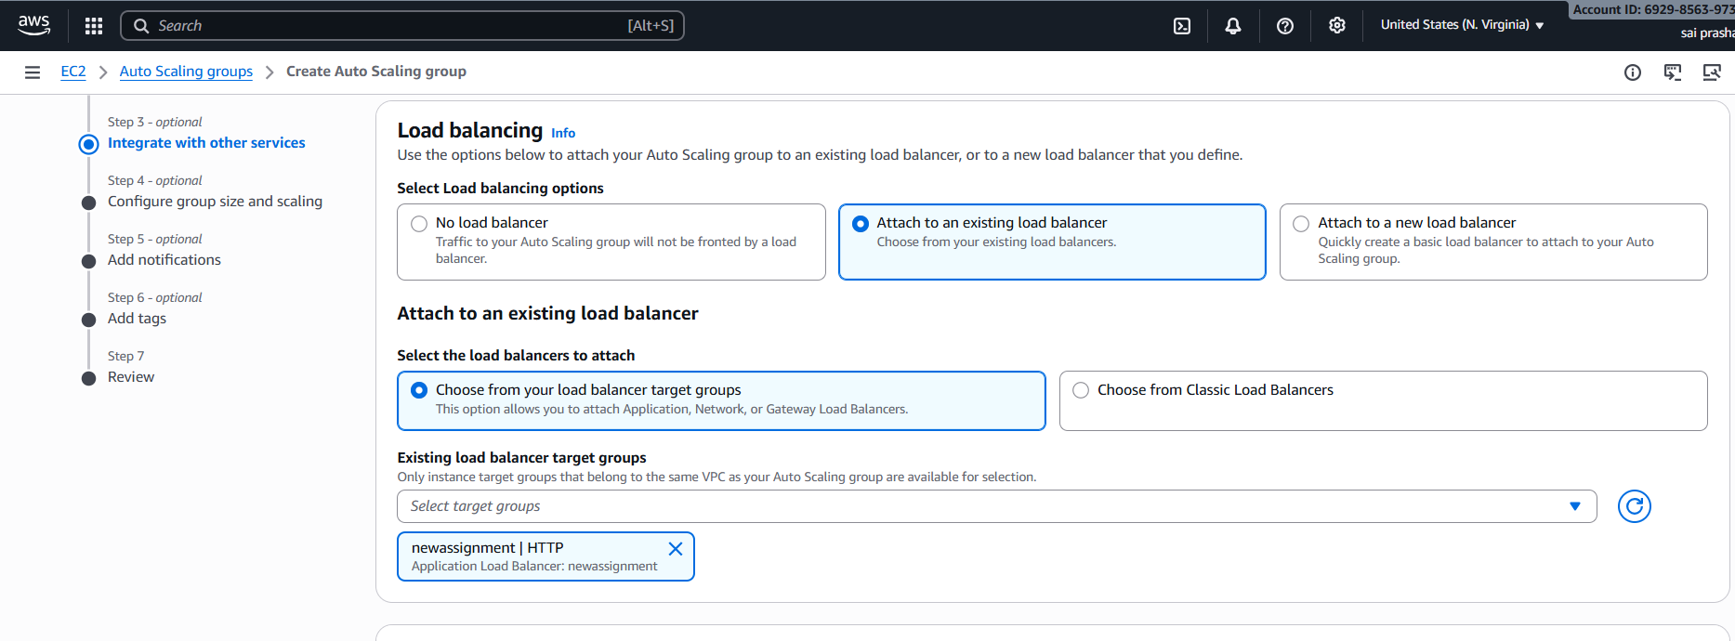

edit the groip size

desired capacity -2

minimum capacity -1

maximum -4

edit the target tracking scaling policy

target value-70

instance warmup-60 and click on next

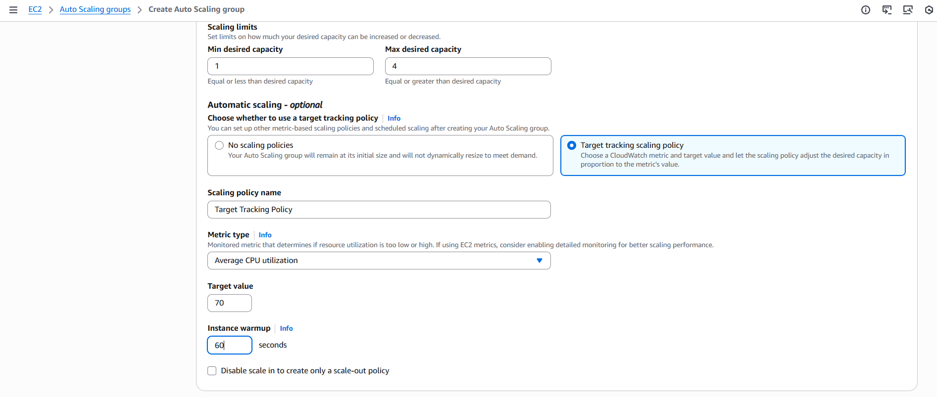

next review the auto scaling

auto scaling has been created

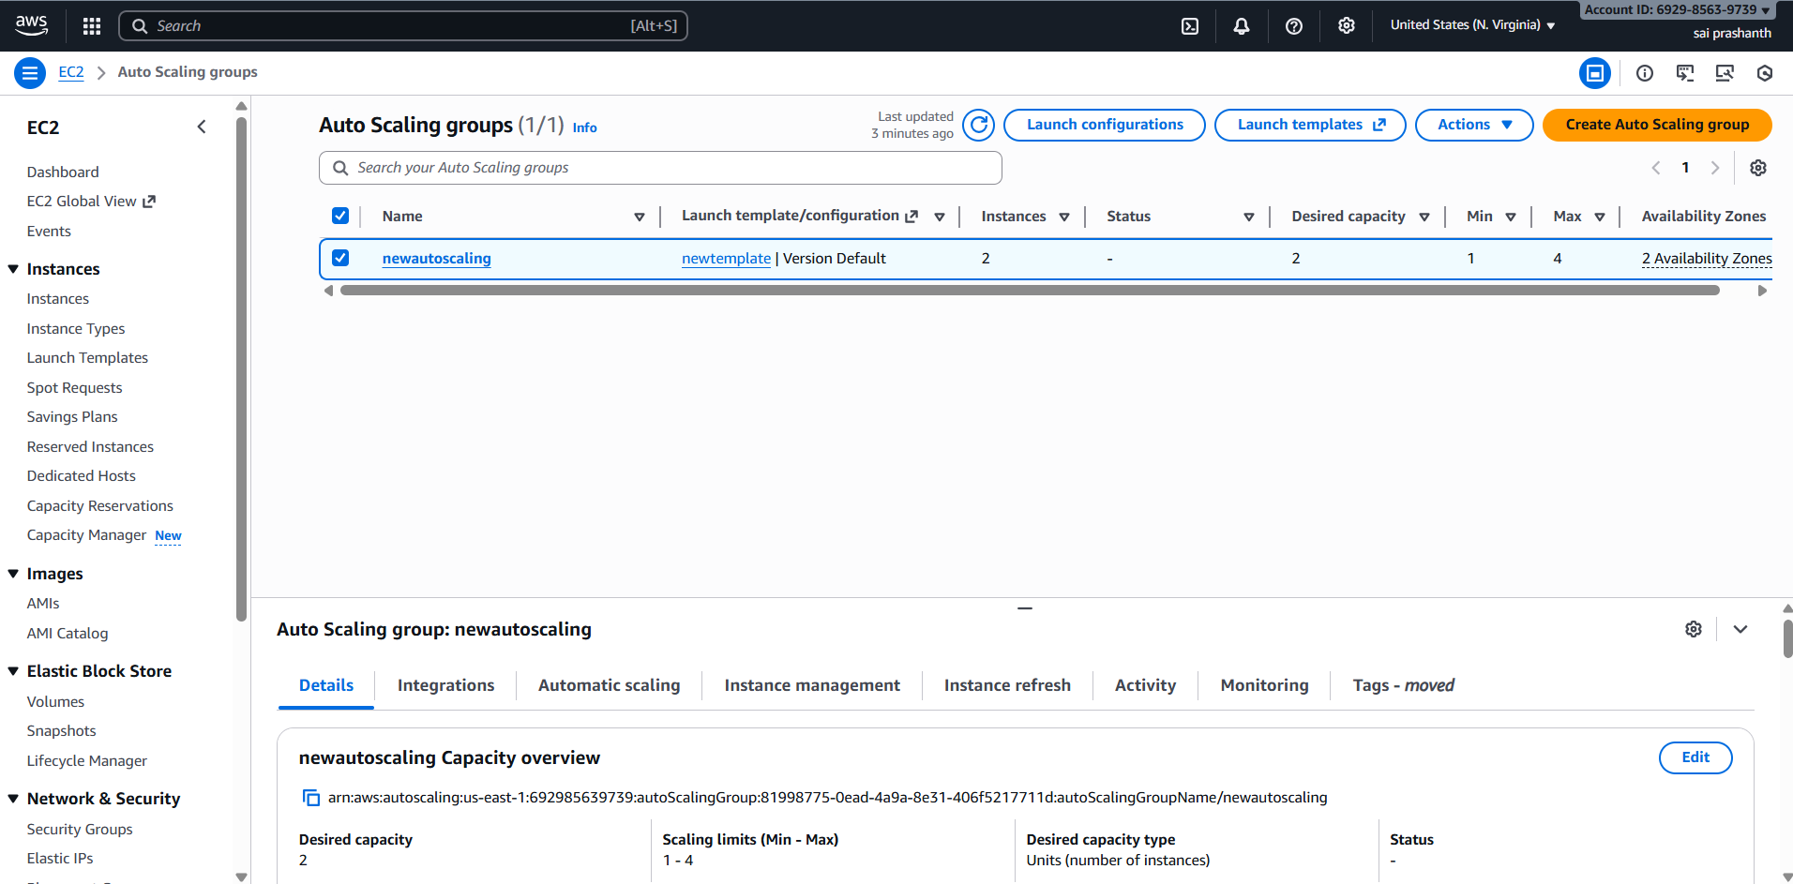

**validation steps:**

if cpu > 70%

it launches new instance automatically

it’s taking time to get initialized

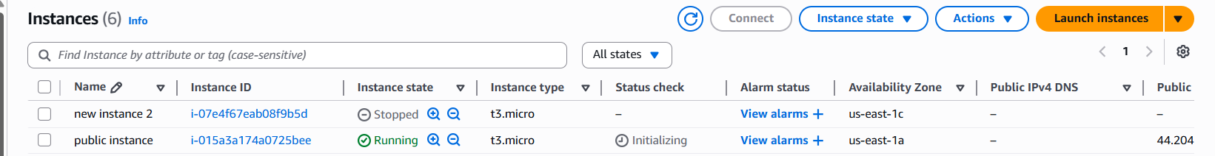

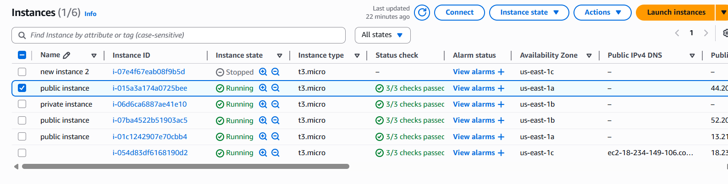

**conclusion**:

Auto Scaling was successfully implemented to monitor CPU utilization and automatically launch a new EC2 instance when usage rises above 70%. This setup improves scalability, maintains performance during peak loads, and ensures continuous availability of the application without manual intervention.